

Permitting Dashboard

Data Entry Application User Guide

Last Updated: September 2023

Training Topics:

1. Prerequisites 3

2. Accessing the Data Entry Application 4

3. My Projects Search View (Log in Landing Page) 5

4. Create or Edit a Project 6

4.1 General Information Tab 6

4.2 Electrical Transmission Checkbox 8

4.3 Location Tab 8

4.4 Organization Tab 10

4.5 Agency Postings Tab 10

4.6 Agency Compliance Tab 15

4.7 Project Sponsor 18

4.8 Outcomes Tab 19

4.9 One Federal Decision Tab 21

4.10 Manage Timetable tab 21

4.10.1 Creating an Action 22

4.10.2 Editing an Action 29

4.10.3 Adding Additional Record of Decisions to an Environmental Impact Statement 30

4.10.4 Setting Project Dependencies 32

5. Section 408 Permit 33

6. Project Workflow 34

6.1 Publishing General Project Information 34

7. Public Website View 36

7.1 Viewing / Searching for Projects 36

7.2 Download or Export of Project Data 37

7.3 Project Map Data 37

8. Extending Dates into Executive Director Review on The Permitting Timetable 39

8.1 Extending Dates into Executive Director Review as a Project Author or Approver 39

9. FAST-41 Missed Dates Process 41

10. Major Infrastructure Projects: One Federal Decision 44

11. Down-Scoping an Environmental Assessment (EA) or an Environmental Impact Statement (EIS) to a Categorical Exclusion (CE) 47

# Prerequisites

In order for a user to gain access to the Permits Data Entry application the user first must have access to the MAX.gov site (henceforth referred to as ‘MAX’). Self-registration is available to Federal government employees and contractors with a Federal government email address and can be registered by visiting <https://max.gov/maxportal/registrationForm.action>.

Federal employees/contractors with a non-government email address as well as non-federal employees performing Federal activities will need to contact a current federal government employee with a MAX account who will act as a sponsor for the non-federal user. The sponsor will need to contact the MAX.gov help desk at: 202-395-6860 or at the following email: [maxsupport@max.gov](mailto:maxsupport@max.gov) for further information on registering the non-federal user.

Once registered with MAX, the user should have their agency dashboard administrator contact: [permittingdashboardfeedback@dot.gov](mailto:permittingdashboardfeedback@dot.gov) and provide the following information:

1. The user’s name
2. The email address this individual used to register with MAX
3. The project(s) for which the user will need access
4. The desired access level, i.e.:

* **Read Only:** Ability to view projects
* **Author:** Ability to view, edit, and create projects
* **Approver:** Ability to view, edit, create, and publish projects for public view

Once the above steps are completed, and confirmed, the user will be able to login to the Permitting Dashboard Data Entry system to begin creating or editing their project information.

**User Permissions Note:**

Currently, each Agency’s **Dashboard Administrators** is responsible for identifying users from their agency and assisting them in gaining access to the Data Entry System to enter/edit project information relative to their given role (**Read Only, Author, Approver**).

**As the Dashboard evolves, Dashboard Administrators may be responsible for limiting user access to specific projects.**

This User Guide will be updated as new capabilities are implemented.

# Accessing the Data Entry Application

Google Chrome or Mozilla Firefox browsers are recommended to access the Permitting Data Entry Application.

To begin, enter <https://cms.permits.performance.gov/user> into your web browser to reach the MAX Login screen:

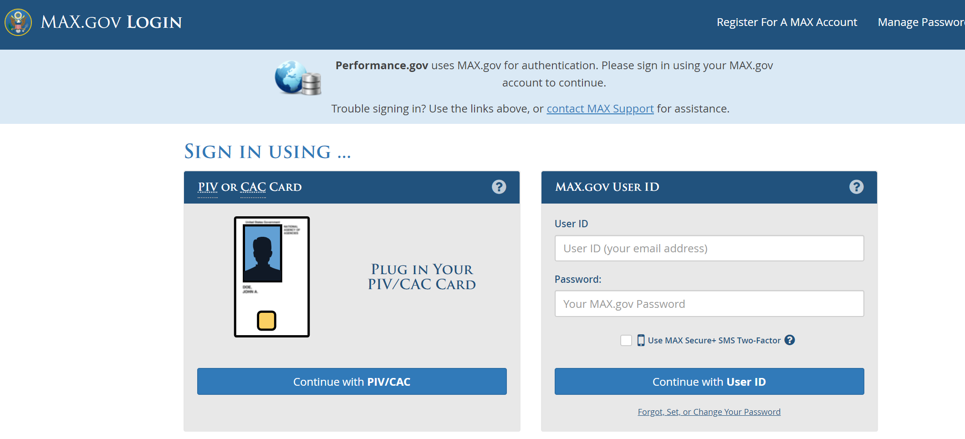

At the MAX login screen, enter your **User ID** and **Password**, and click LOGIN WITH USER ID to be directed to the Permitting Data Entry Application. Note: Max.gov implemented 2-factor authentication in July 2023.

If you do not know your MAX Login information, click the FORGOT, SET, or CHANGE YOUR PASSWORD link.

If you are not registered in the MAX system, click the REGISTER FOR A MAX Account link at the top right of the login screen.

# My Projects Search View (Log in Landing Page)

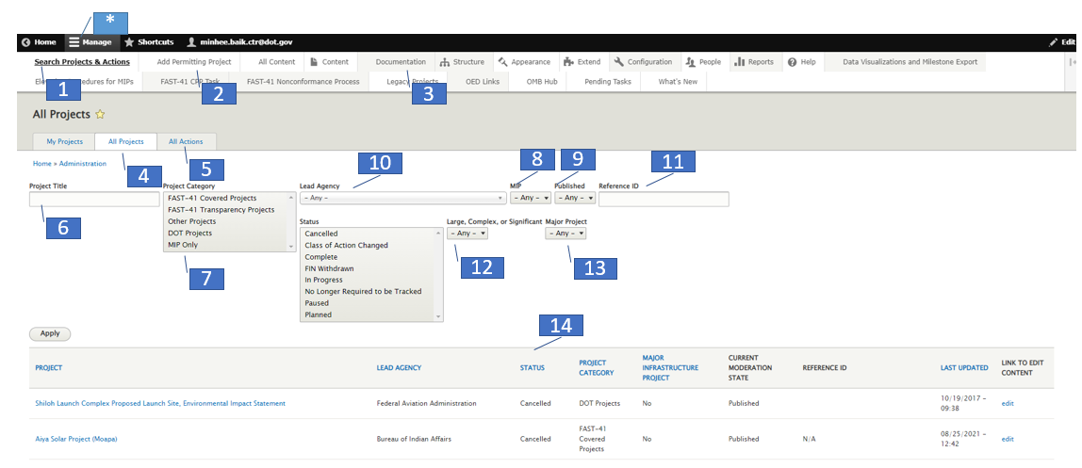

Upon logging in to the Permitting Data Entry Application, you will first be presented with a “projects search” view page and an admin menu visible at the top**.** This is the ‘home page’ for interaction with your Permitting Projects. Key features are noted below.

Admin Menu (**\*Note** – if you are not able to see the following items, please select the “Manage” link first)

1. **Search Projects & Actions** – Click here to return to the projects search view
2. **Add Permitting Project** – Creates a new project
3. **Documentation** – Hover over this menu item to reveal several useful documents such as the data entry user guide (this user guide) and the data management guides

Projects Search View:

1. **All Projects** – Click here to return to the project search view page
2. **All Actions** – Click here to view a table that allows you to view sort and filter all Actions within Projects
3. **Project Title** – Search projects by project title
4. **Project Category** – Filter projects by one or more project categories. To filter by multiple categories, hold the CTRL key and click on each category. To unselect a category, hold the CTRL key and click the category again.
5. **MIP** – Filter projects by Major Infrastructure Projects (Yes/No)
6. **Published –** Filter projects that are not published or published
7. **Lead Agency –** Filter project by Lead Agency
8. **Reference ID –** Filter by a project’s reference ID (if one is entered)
9. **Large, Complex, or Significant** – Filter by a project that is large, complex, or significant (Yes/No)
10. **Major Project** – Filter by a project that is a major project (Yes/No)
11. **Status –** Filter projects by one or more statuses. To filter by multiple statuses, hold the CTRL key and click on each status. To unselect a status, hold the CTRL key and click the status again.

# Create or Edit a Project

The following section outlines the process used to create a new Permitting Project or to edit an *existing* Permitting Project.

## General Information Tab

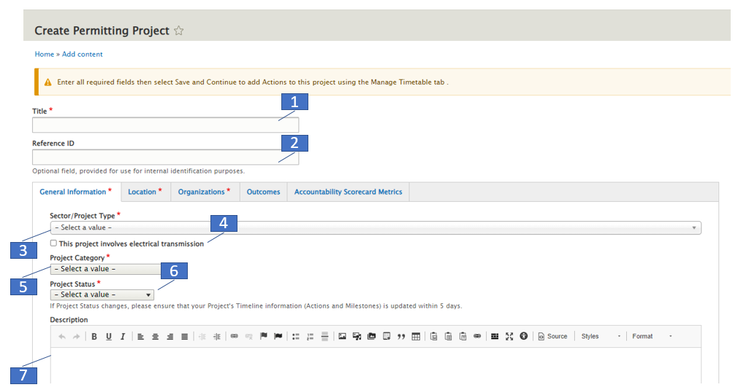

To create a new project, follow the steps below. Note: Fields marked with a red asterisk are required to be entered.

1. **Title \*** – Enter the title for your project
2. **Reference ID** – This is an optional field that can be used to tie back to the agency’s system
3. **Sector / Project Type \*** – Select the Sector of the Project
4. **Electricity Transmission Projects** – Transmission projects, look for this checkbox below the description field. This box **must be checked** in order to reveal the additional Electricity Transmission project fields.
5. **Project Category \*** – Select from: FAST-41 Covered Projects, FAST-41 Transparency Projects, Other Projects, or DOT Projects.

If ‘DOT Projects’ is selected as a Project Category, then the following fields will appear and are required:

1. Major Project – Yes or No. The field defaults to No.
2. Large, Complex, or Significant – Yes or No. The field defaults to No.
3. **Project Status\*** – Select from PLANNED, IN PROGRESS, PAUSED, COMPLETE, CLASS OF ACTION CHANGED or CANCELLED

If the project status is set to **Paused**, then you will be required to enter:

* 1. The effective start date of the pause
     1. Users are required to enter an effective pause end date once the project is resumed
  2. An explanation for the start of the pause
     1. Users are required to enter an explanation for the ending of the pause status once the project is resumed
  3. A reason for the pause from only one of the following selections:
* Local Government Factors
* State Government Factors
* Tribal Government Factors
* Natural Disasters
* Pending Legal Action
* Project Sponsor Factors

1. **Description** – Enter general information about the project

**\*** Indicates a required field

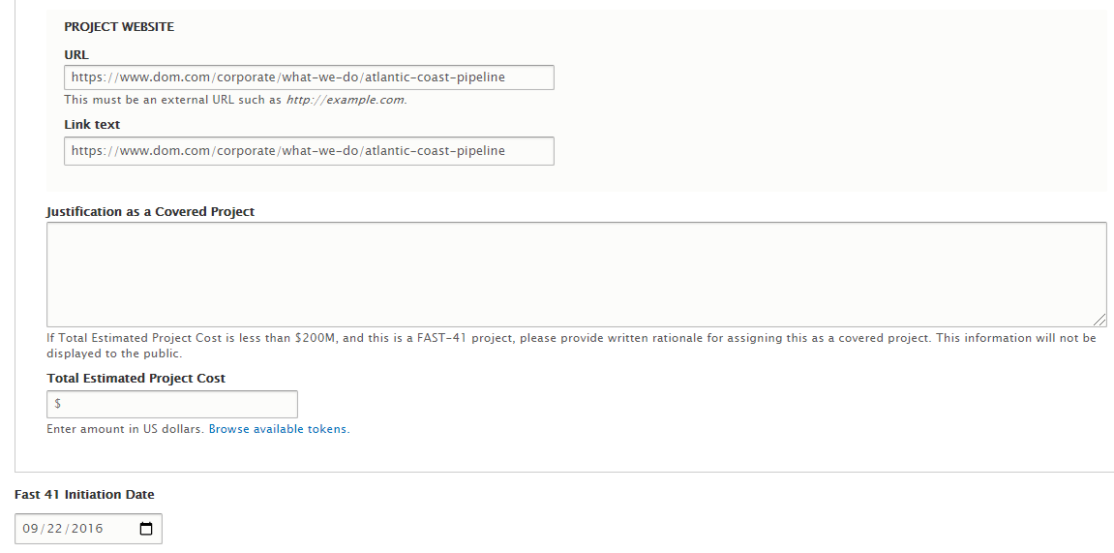

4

3

2

1

1. **Project Website –** Enter the project’s website (if applicable) . Ensure to enter the full url starting with https://
2. **Justification as a Covered Project –** Populate this field if the project cost is identified as under $200M, according to directions in the Help Text. This field is for FAST-41 project only.
3. **Total Estimated Project Cost –** This field is not required for FAST-41 Projects. DOT projects should enter this information. The cost will display on the front-end if entered. *This field accepts only numbers, no other symbols or text.*

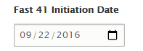

1. **FAST-41 Initiation Notice (FIN) date (Executive Director viewable field ONLY) –** This field is only editable and viewable for users with the Executive Director role. This field is used to enter the FAST-41 Initiation Notice date for the project. The date populates the project’s Gantt chart with an icon to visually indicate the FIN date.

## Electrical Transmission Checkbox

If the ‘This project involves electrical transmission’ (#1) checkbox is selected, additional fields will display as listed below.

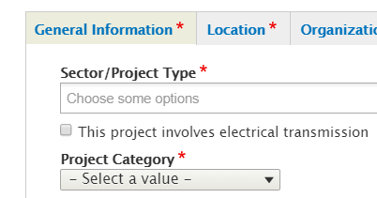

1

Additional Electricity Transmission fields include:

* 216(h) Qualification checkbox
* Voltage
* Number of Circuits
* Current Type
* Circuit Type
* Approximate Length
* Point of Origin: City, State, Substation
* Point of Terminus: City, State, Substation
* Proposed in Service Date

## Location Tab

The location tab allows entry of multiple locations for each project, if desired. You may enter as many locations as applicable, using Street Address, Lat/Long coordinates, or a combination of the two formats.

Only the location that is marked as ‘Project Primary Address’ will appear on the map on the project’s page

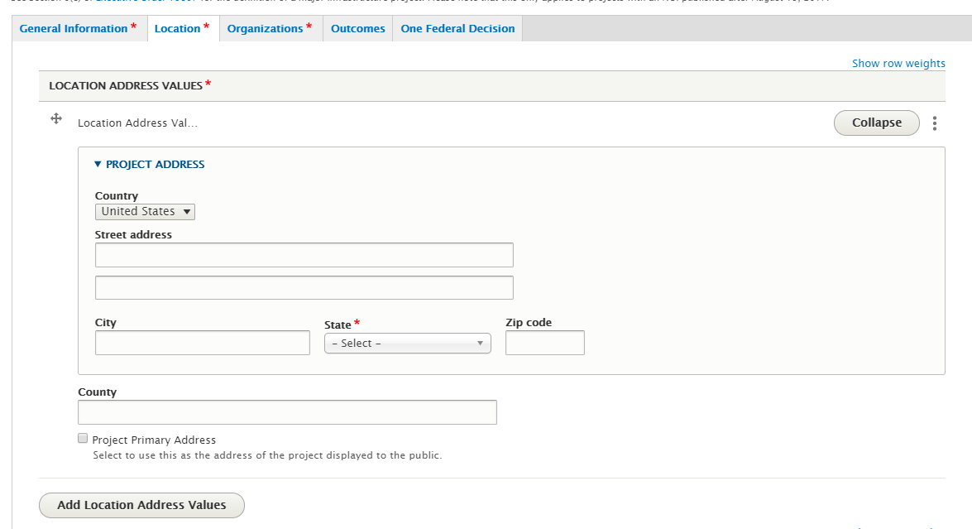

3

2

1

1. **Project Street Address** – Enter the project’s location via street address
2. **Project Primary Address** – This checkbox will set project’s street address as the project’s primary location and will display under the Location section on the project page.
   1. A State must be entered for a project’s location.
3. **Add Location Address Values** – Allows you to enter additional street addresses for the project’s location

**Latitude/Longitude**

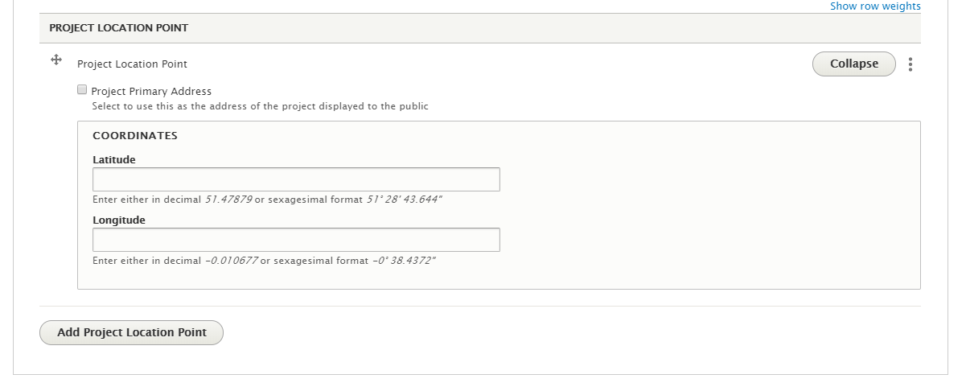

31

21

1

1. **Coordinates –** Enter the project’s location by latitude and longitude coordinates
2. **Project Primary Address** – This checkbox will set the coordinates as the project’s primary location and will display under the Location section on the project page.
3. **Add Project Location Point** – Allows you to enter additional coordinates for the project’s location

## Organization Tab

The Organizations Tab is used to capture parties involved in the Project’s permitting process, including the lead agency and project sponsors. Please populate as much information as possible to maximize transparency and accountability in the Permitting process.

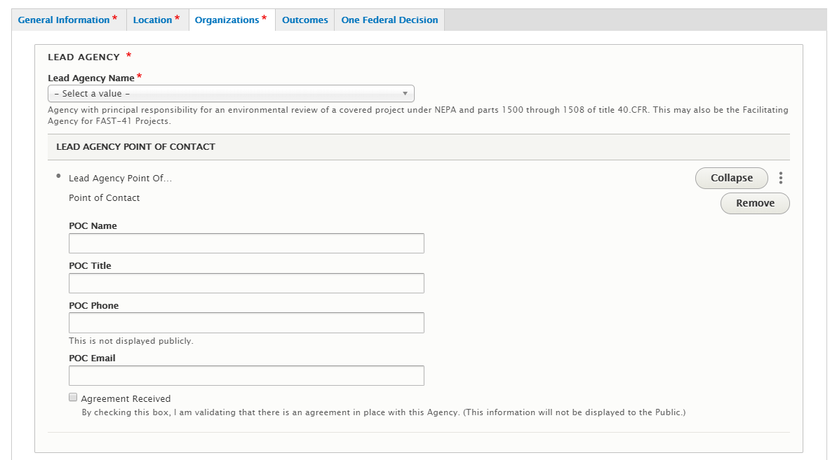

31

21

11

1. **Lead Agency and Bureau/Mode** – Enter the lead agency of the project
2. **Lead Agency Point of Contact** – Enter the applicable Lead Agency point of contact information
3. **Agreement Received** – This field is available for the Lead Agency and Project Sponsor fields. Check this box to track whether or not an agreement has been received from the organization.

## Agency Postings Tab

The Agency Tab is used to supports agency compliance with the “Postings by agencies” requirements of FAST-41. FAST-41 requires the facilitating/lead agency and each cooperating and participating agency to post publicly certain information directly to the Dashboard without Executive Director involvement. This information is identified at 42 U.S.C. § 4370m-2(b)(3)(A). If any required information is already posted on the Dashboard (even by another agency), agencies may cross reference to the location of that information on the Dashboard.

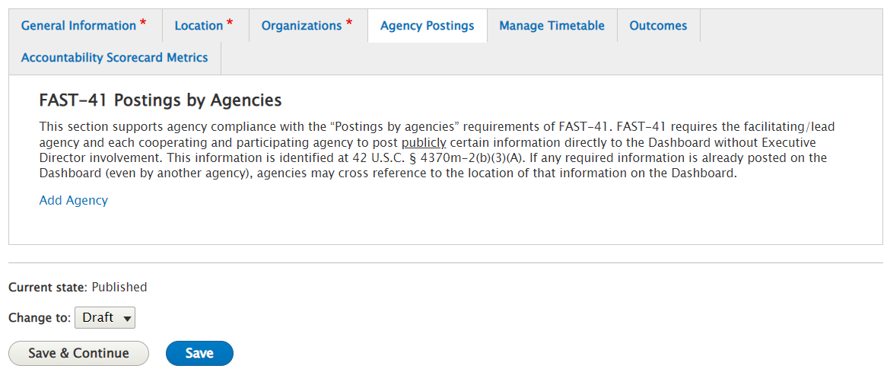

1. **Add Agency** 
   1. Select Agency - This field contains a drop down list of Agencies that can be selected.

1.1

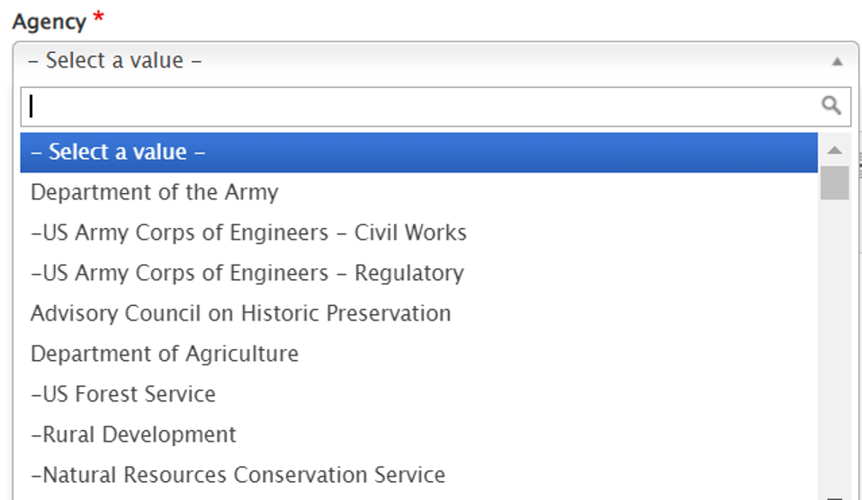

* 1. This Field is used to provide a hyperlink that directs to a website that contains the FAST-41 Initiation Notice. Upload a copy of document if it is not available by hyperlink. Do not include proprietary or confidential information.
  2. Provide a hyperlink that directs to a website that contains the application and supporting documents that have been submitted by a project sponsor for any required environmental review or authorization or a notice explaining how the public may obtain access to such documents. Upload a copy of relevant documents that are not available by hyperlink. Note whether provision of applications and supporting documents is not practicable or applicable.

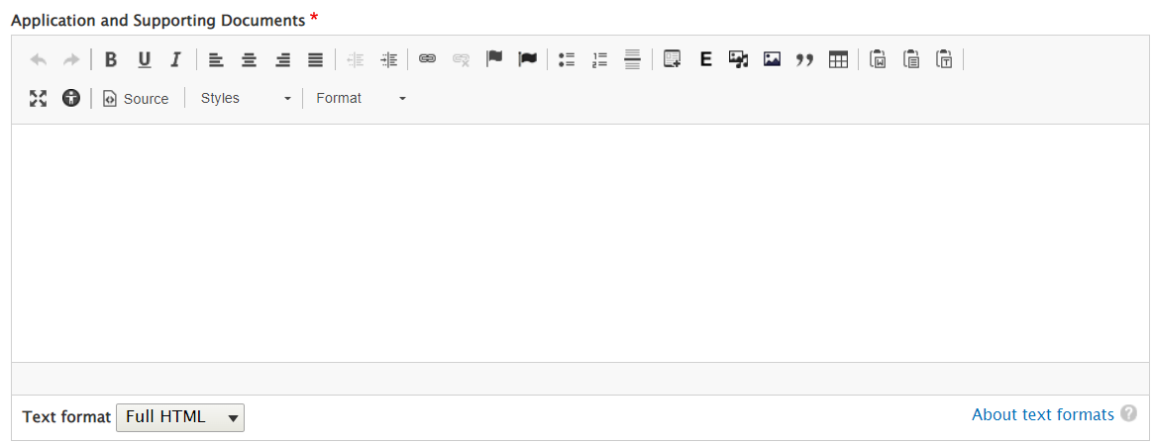

* 1. Provide a hyperlink that directs to a website that contains a description of any Federal agency action taken or decision made that materially affects the status of the project and significant documents that support the actions/decisions. Upload a copy of relevant documents that are not available by hyperlink. Note whether this description is already reflected through the project’s permitting timetable or elsewhere on the Dashboard

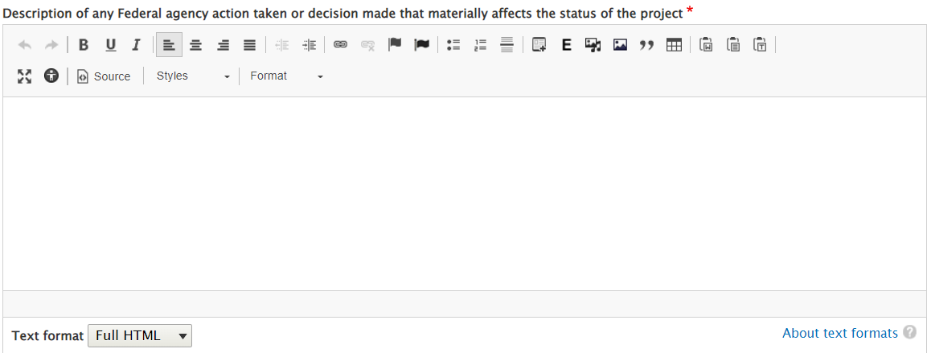

* 1. Provide information on the status of mitigation measures that were agreed to as part of the environmental review and permitting process, including whether and when the mitigation measures have been fully implemented. Upload a copy of relevant documents that are not available by hyperlink.

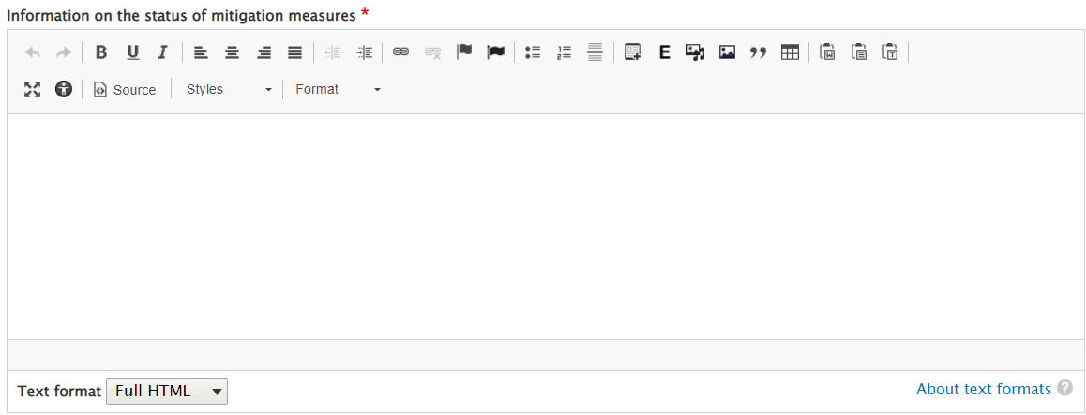

* 1. Provide a description of the status of any litigation to which the agency is a party that is directly related to the project, including, any judicial document made available on an electronic docket maintained by a Federal, State, or local court. Upload a copy of relevant documents that are not available by hyperlink. Note whether provision of judicial documents is not practicable.

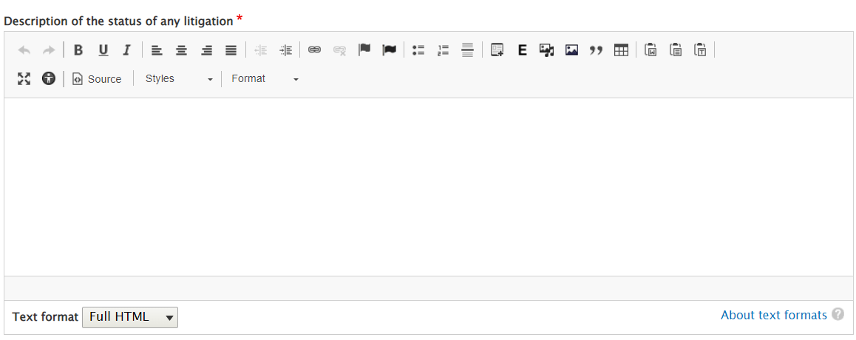

* 1. Provide information about project-related public meetings, public hearings, and public comment periods, presented in English and the predominant language of the community or communities most affected by the project, as that information becomes available. A link to such information is not sufficient.

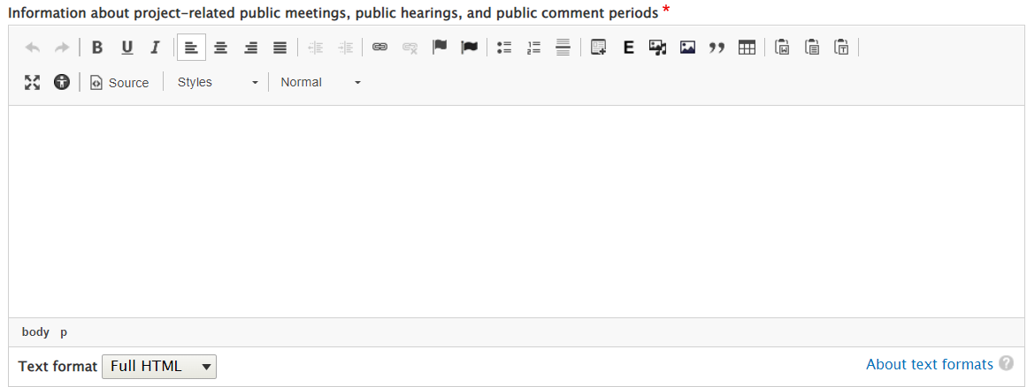

1. **Select Save** – This button allows user to save all entered data.
2. **Verify success banner**

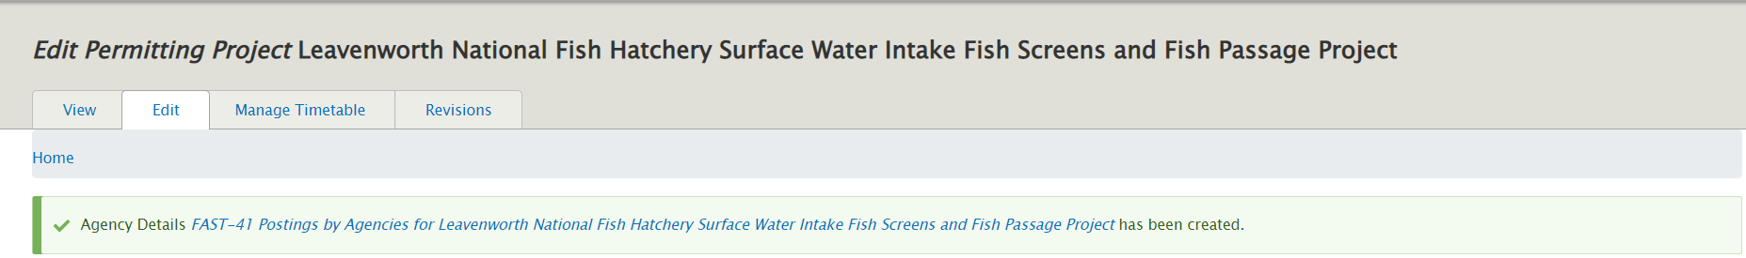

1. **Navigate back to Agency Postings tab and Click on Edit**

**4.1 Edit allows users to update the status from Draft to Needs Review**

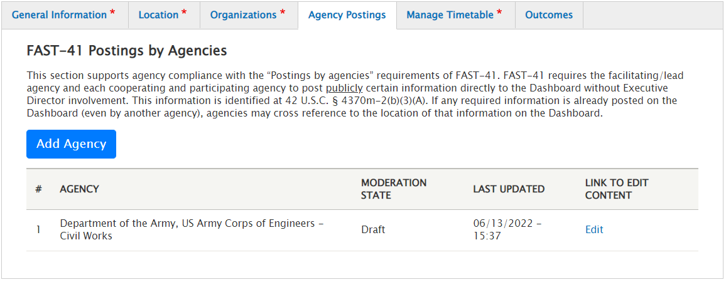

4.1

1. **Select a new status from the dropdown ‘Needs Review’ and select Save**

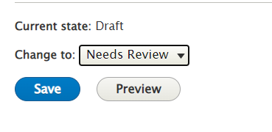

1. **Verify Success banner.**

## Agency Compliance Tab

The Agency Compliance Tab is used to supports agency compliance with the “Postings by agencies” requirements of FAST-41.

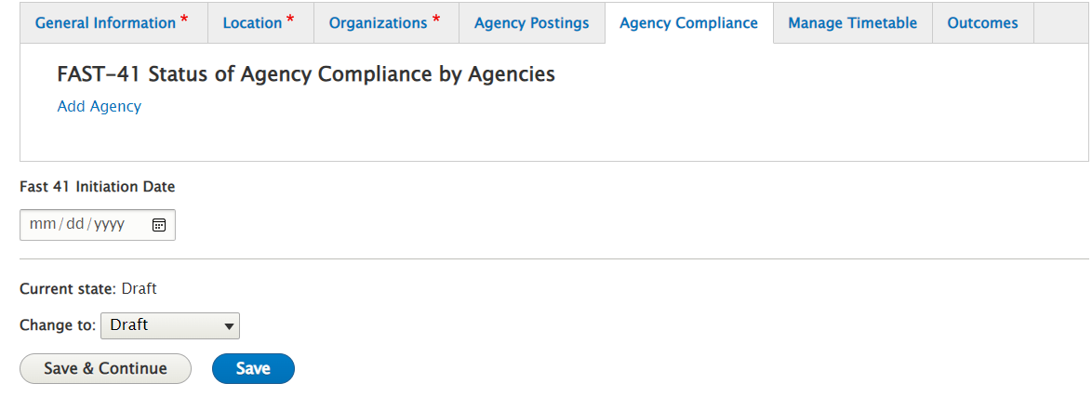

**1. Add Agency**

1.1Select Agency - This field contains a drop-down list of Agencies that can be selected.



1.1

**2. Select Compliance Status and enter Compliance Status Date**

2.1 Check a Radio button for Agency Compliance Status

2.2 Enter Compliance Status Date

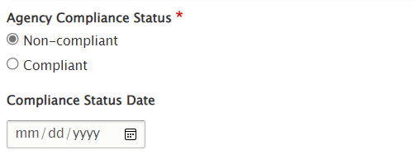

2.1

**3. Select a reason from the drop down**

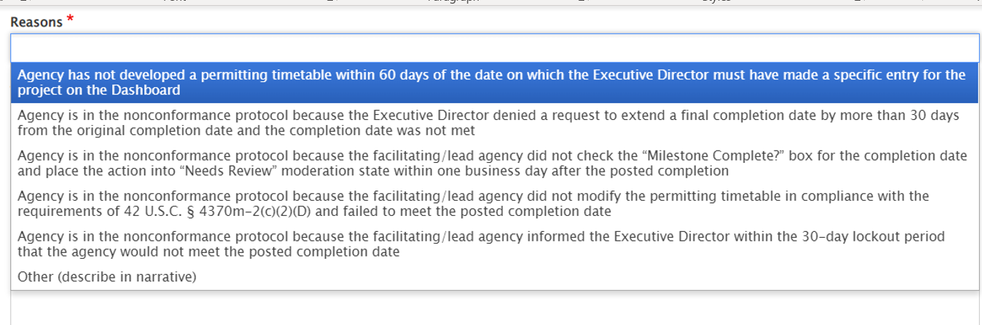

**4. Enter Additional Details**

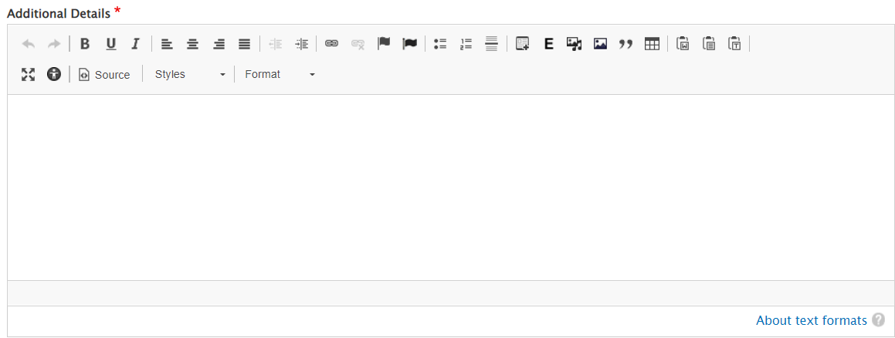

**5. Enter OED Internal Comments**

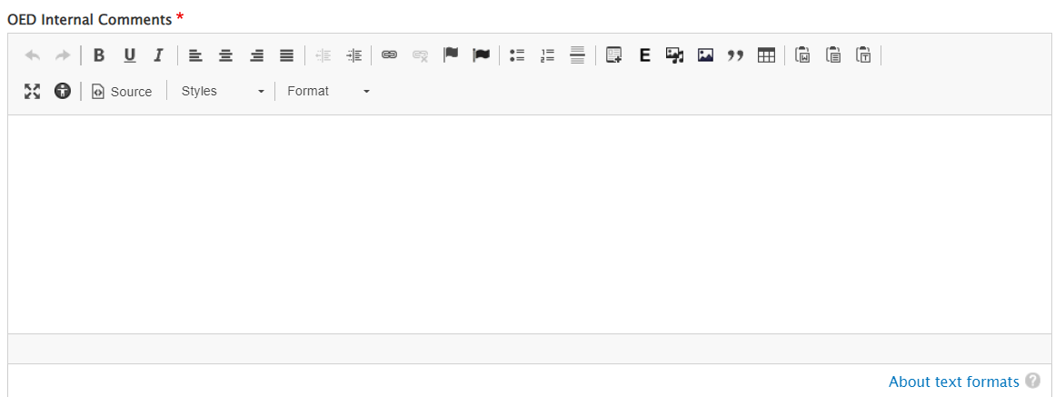

**6. Select Save and** **Verify Success banner.**

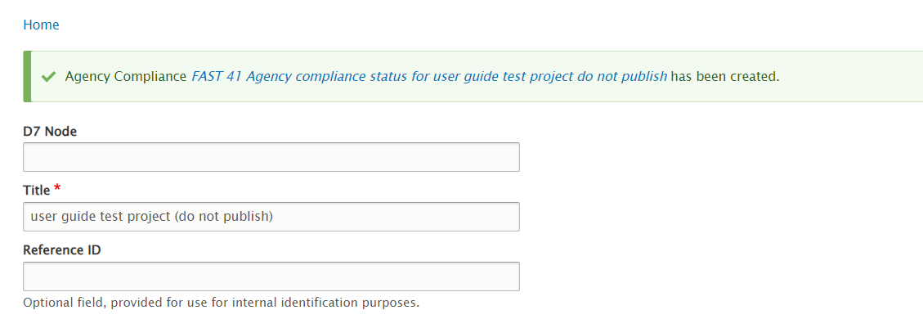

Navigate to the bottom of the screen and update the status from Draft to Needs Review

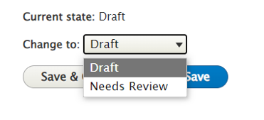

Select Save

From the home screen change the status to Published and click Apply

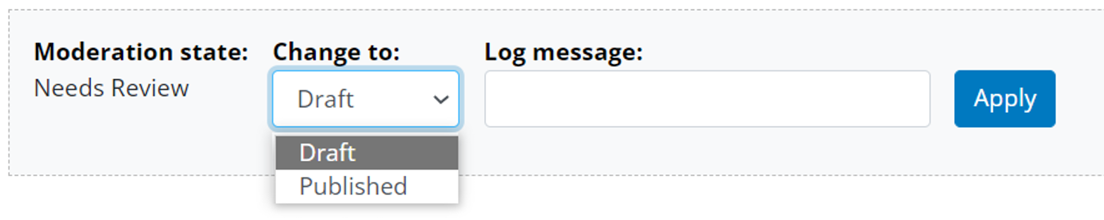

**Verify Success banner**

## Project Sponsor

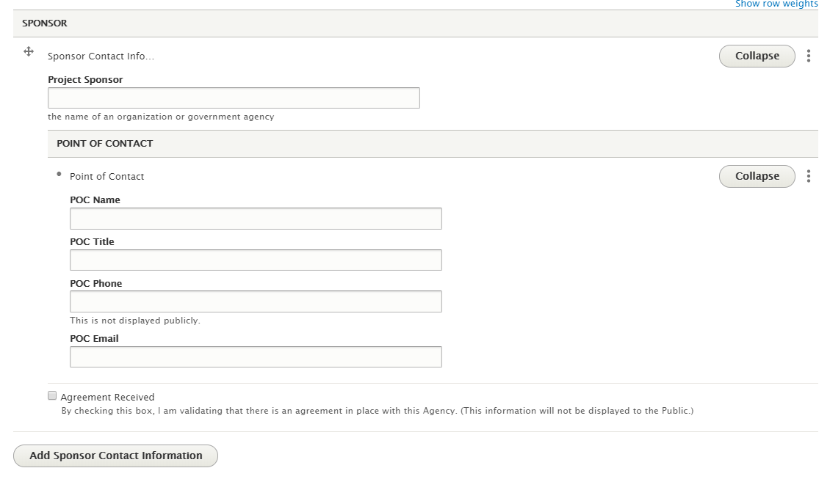

51

6

1. **Project Sponsor** – Enter the applicable project sponsor point of contact for the project
2. **Agreement Received** – This field is available for the Lead Agency and Project Sponsor fields. Check this box to track whether or not an agreement has been received from the organization

## Outcomes Tab

The Outcomes tab allows entry of Environmental and Community Outcomes which are the qualitative and quantitative descriptions of how a project’s projected effects change over time and the community-based processes and mitigation measures developed to address those effects.

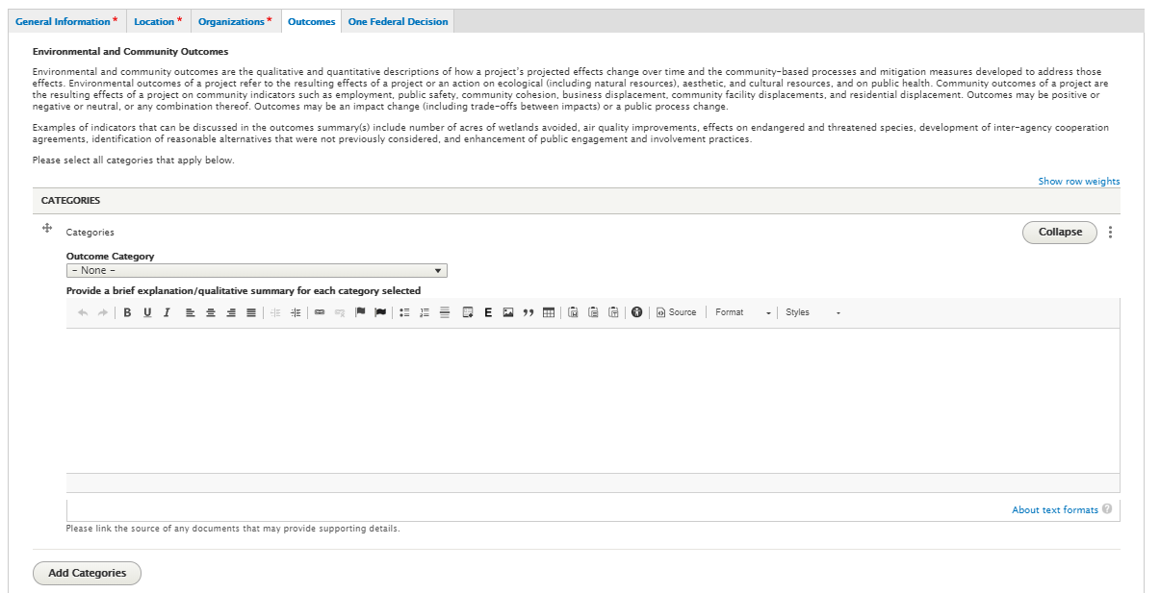

41

31

21

11

1. **Outcome Category –** This field contains a drop down list of Categories that can be selected. The followinig Categories are avalble for selection

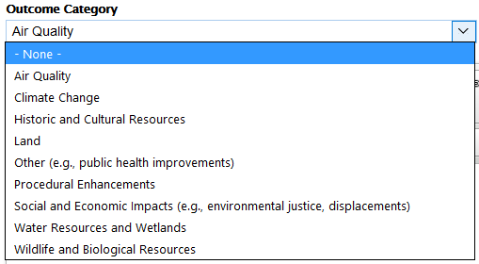

1. **Provide a brief explanation/qualitative summary for each category selected –** Use this text field to provide additional details of the Category selected.
2. **Add another category –** Selecting this will allow for additional Categories to be selected
3. **Remove category –** Selecting the three dots will give you an option to remove any additional categories entered

At the bottom of the Outcomes Tab page there is a question with checkbox selections

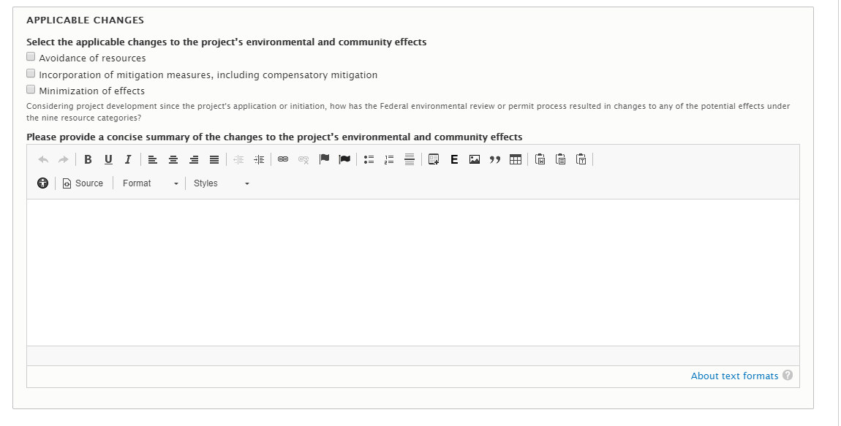

21

11

1. **Select the applicable changes to the project’s environmental and community effects** – Multi checkbox selection
2. **Please provide a concise summary of the changes to the project’s environmental and community effects –** Provide details and any additional information in this text box

## One Federal Decision Tab

Please see **Section 9** of this document for information regarding Major Infrastructure Projects and the One Federal Decision tab.

## Manage Timetable tab

Once you have entered all required fields for the project, select Save and Continue to start entering Actions for your project using the Manage Timetable tab.

The Manage Timetable tab is where Permitting Projects’ Timetable information will be created and updated.

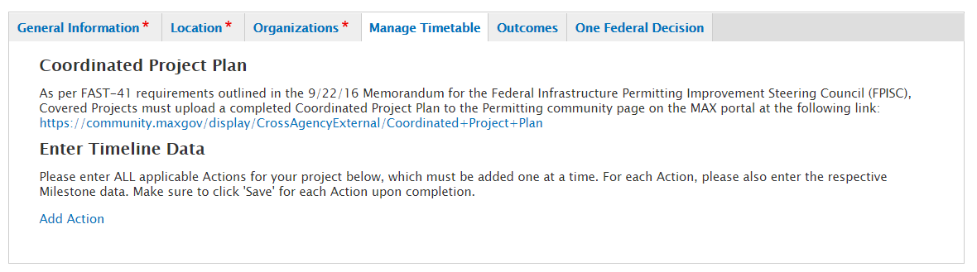

21

11

ACTION is an umbrella term used to include Permits, Abbreviated Reviews, and Authorizations.

1. **Coordinated Project Plan** – Per FAST-41 legislation, all Covered Projects must upload a completed Coordinated Project Plan to the Permitting community page on the MAX portal at the following link: <https://community.max.gov/x/NoGPQw> no later than 60 days after the project has been posted to the Dashboard.
2. **Add Action** – Select this link to add each ACTION for your Project

### Creating an Action

From the ‘Timeline Tab’, select the ‘Add Action’ link



Once selected, you will be taken to the Permitting Action form as shown below

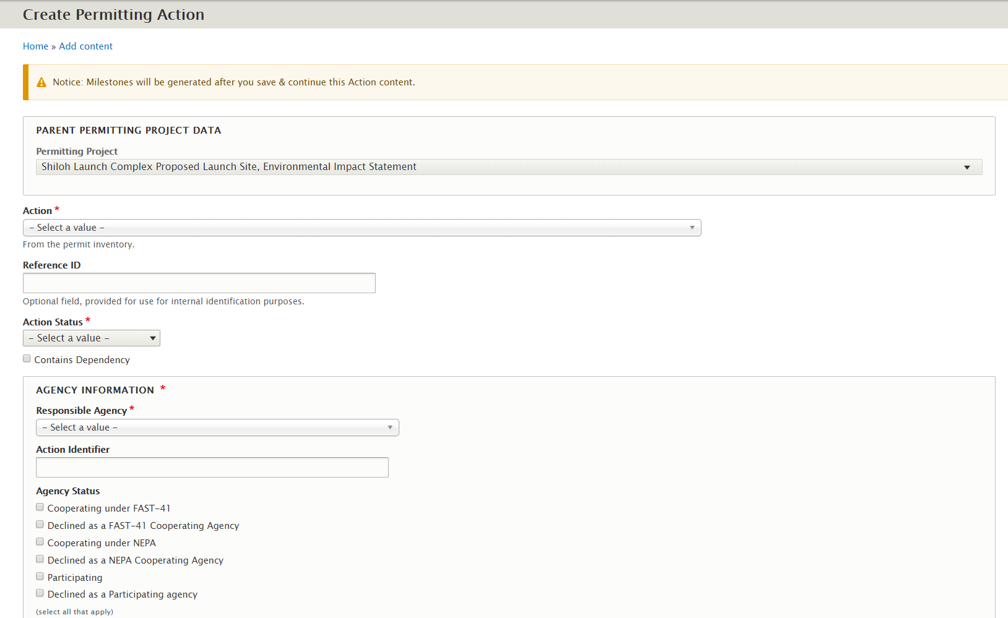

71

61

51

41

31

21

11

1. **Action** – A pre-populated set of Actions will appear in this dropdown (Section 106, EIS, EA, Section 404 Clean Water Act etc.)
2. **Reference ID** – This is an optional field that can be used to tie back to the agency’s system and is not public facing.
3. **Status** – Select the Action’s status. If “paused” is selected, several checkboxes will appear that will allow you to select a primary reason for the paused status. The reasons are as follows:
   1. Local Government Factors
   2. State Government Factors
   3. Tribal Government Factors
   4. Natural Disasters
   5. Project Sponsor Factors
4. **Contains Dependency** – Allows you to indicate whether the Action contains a dependency to another Action within the project.
5. **Responsible Agency** – Indicate the Agency that is responsible for the Action.
6. **Action Identifier** – Allows the ability to enter a phrase that would uniquely identify the Action such as entering the district or region of the Action.
7. **Agency Status –** If Declined as a NEPA Cooperating Agency or Declined as a Participating Agency is selected then additional check box options display

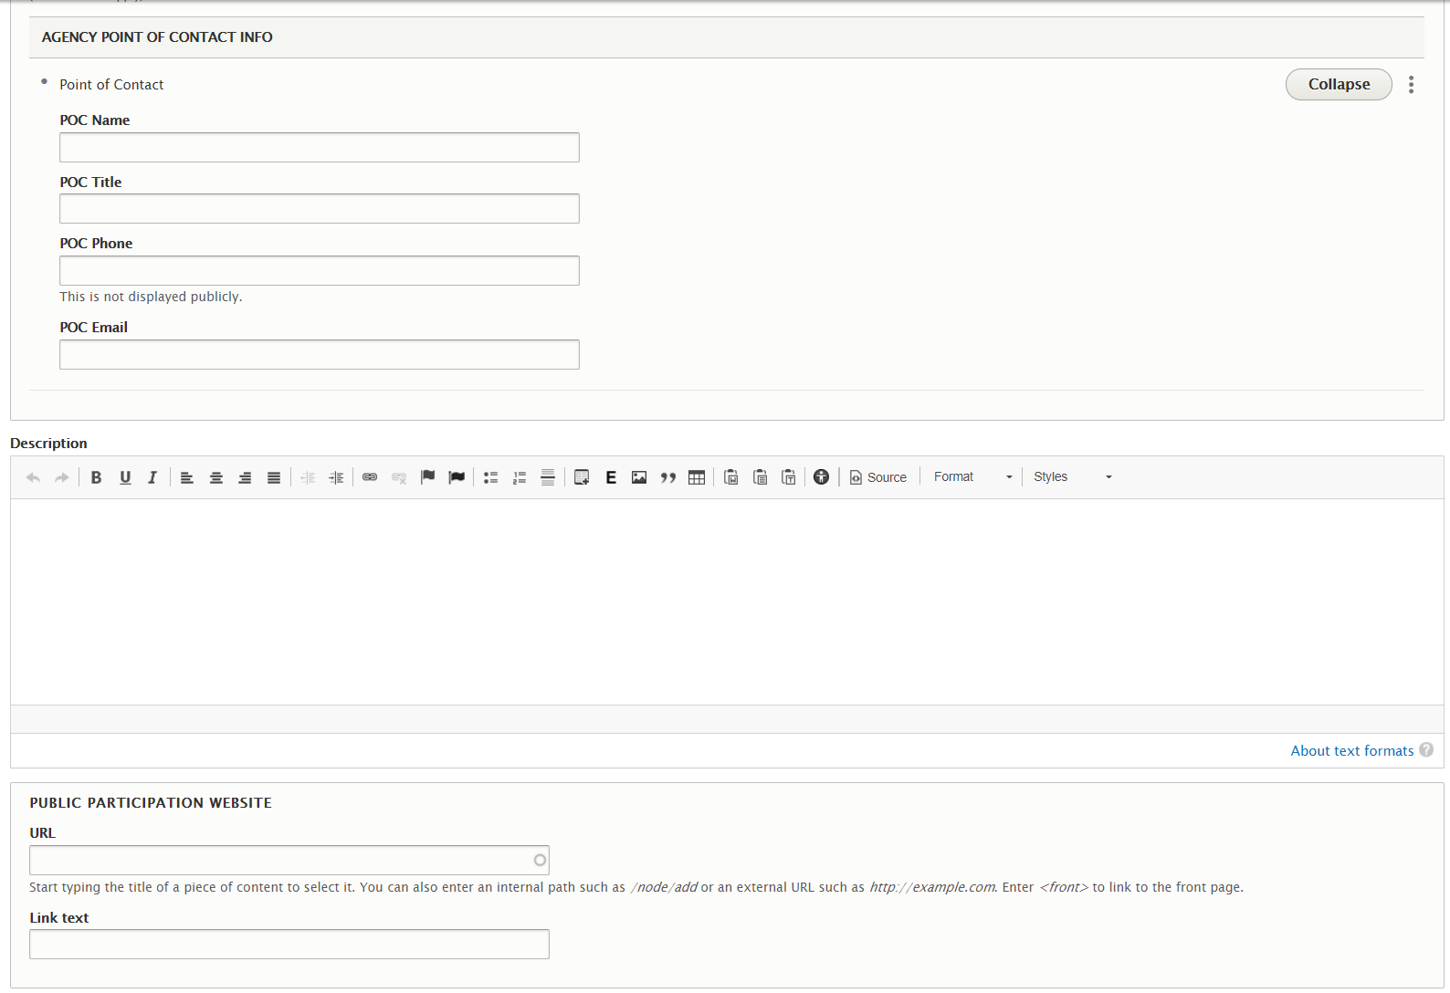

10

81

91

1. **Agency Point of Contact Info –** Indicate the Responsible Agency point of contact information. Phone numbers are not be publicly displayed.
2. **Description –** Add any information that you may deem necessary and beneficial for the public to know about the Action.
3. **Public Participation Website** **–** Enter the Public Participation Website for the Action if applicable.

11

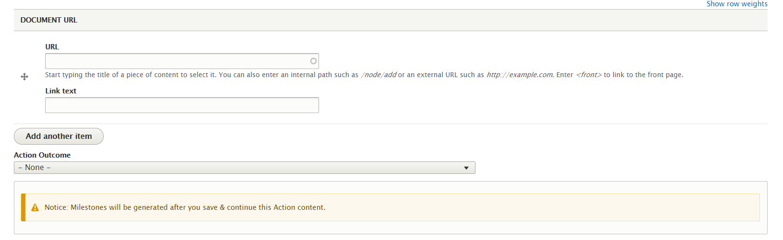

12

1. **Document URL** **–** Enter any documents that are related to the Action if applicable.
2. **Action Outcome –** A selection for the Action Outcome field is currently only needed for two Actions, Section 106 and the Endangered Species Act Actions. A selection is required when the final milestone is marked as ‘completed’ for the Section 106 and the Endangered Species Act Action.

Once all Required fields are entered select Save and Continue to enter milestone data for the Action. The milestone will appear at the bottom of the form after selecting “Save and Continue”



e1

b1

a1

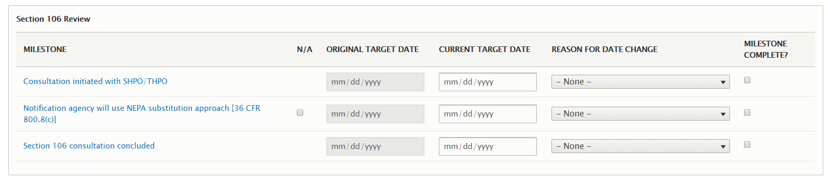

d1

c1

1. **Milestones** 
   1. **N/A:** Allows you to indicate whether the milestone is not applicable to the Action.
   2. **Original Target Date:** This field will automatically populate with the ‘Current Target Date’ entered for each milestone once the Action’s status is published as ‘In Progress.’ The Original Target Date serves as a field to view the initial target date entered for the milestone during the permitting process.
   3. **Current Target Date:** Enter the Current Target Date for each milestone.
   4. **Reason for Date Change:** Allows you to indicate from a pre-populated list of reasons for why a milestone’s Current Target Date has been updated. A Reason is only required for a milestone if the milestone’s date has been updated.
   5. **Milestone Complete?** Allows you to indicate when a milestone is completed. Milestones can’t be marked as completed with a future target date entered.
2. **Optional Milestones**

Additional milestones that are not part of the required set of milestones can be entered for an Action. Below the required milestone, select the Add Optional Milestones button.

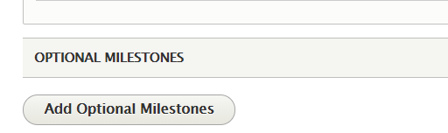

Notice that a set of fields appear to add the optional milestone

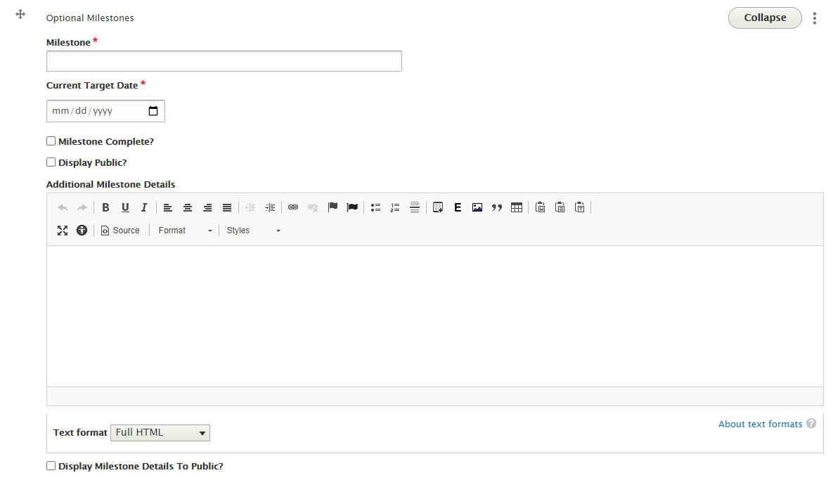

f

e1

c,d

b1

a1

* 1. **Milestone:** Enter a name for the optional milestone
  2. **Current Target Date:** Enter the Current Target Date for the optional milestone.
  3. **Milestone Complete?** Allows you to indicate the milestone as completed
  4. **Display Public?** Allows you to hide or show the optional milestone on the public facing site.
  5. **Additional Milestone Details:** Enter details/information related to the optional milestone
  6. **Display Milestone Details to public?** Allows you to hide or show the details entered for the milestone on the public facing site

To add more optional milestones, select the “Add Optional Milestones” button again as seen above and repeat steps a-f.

To Remove an optional milestone, select the three dots icon as noted below and select “Remove”

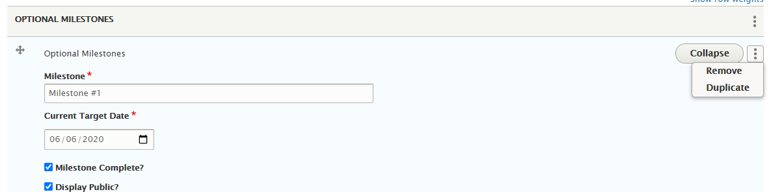

1. **Saving Action Data/Submitting for Review**

The Save buttons and options are located at the bottom of the Action data entry form. Details about these buttons are below:

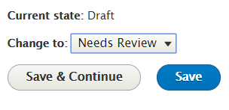

41

31

21

11

1. **Current State:** The current revision state of the Action
2. **Change to:** Allows you to submit the Action to the Needs Review workflow state for the Lead Agency to review for publishing. Once Needs Review is selected, select “Save & Continue” or “Save” to submit the Action to Needs Review
3. **Save and Continue**: Once at the bottom of the form, selecting “Save & Continue” will save all the data entered on the form and you will remain on the form to continue to add/edit data.
4. **Save:** If you are ready to Save your Action and view the draft which you just created, select the ‘Save’ button at the bottom of the form. You can also move the Action through the workflow as you are viewing the Draft as noted below:

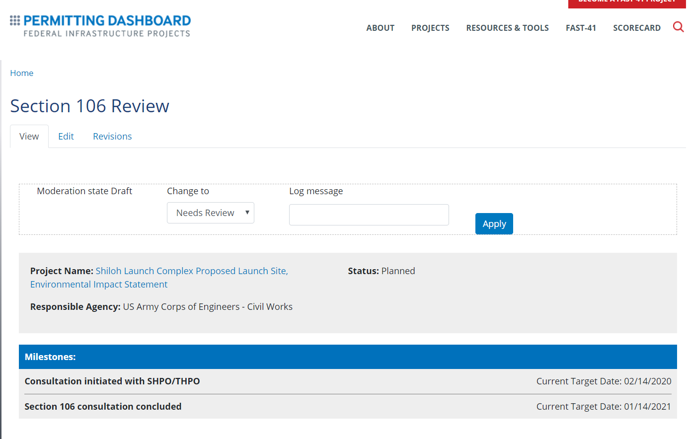

21v

31v

21v

11

1. **View:** After selecting ‘Save’ you will be taken to the page to view your draft. The draft is a page that shows you exactly what the Action page will look like before it is ‘Published’ to be public facing.
2. **Edit:** If you are not ready for the Draft to be public facing and would like to continue making edits, then select the ‘Edit Draft’ button.
3. **Moderation State:** When a project *AUTHOR* creates, or edits an Action, that information is saved in a **DRAFT** state. Actions will remain in **DRAFT** until an *AUTHOR* sets the status to **NEEDS REVIEW**; at which point they should manually/orally inform a project *APPROVER* that the Action is ready for review and publication to the public-facing website.

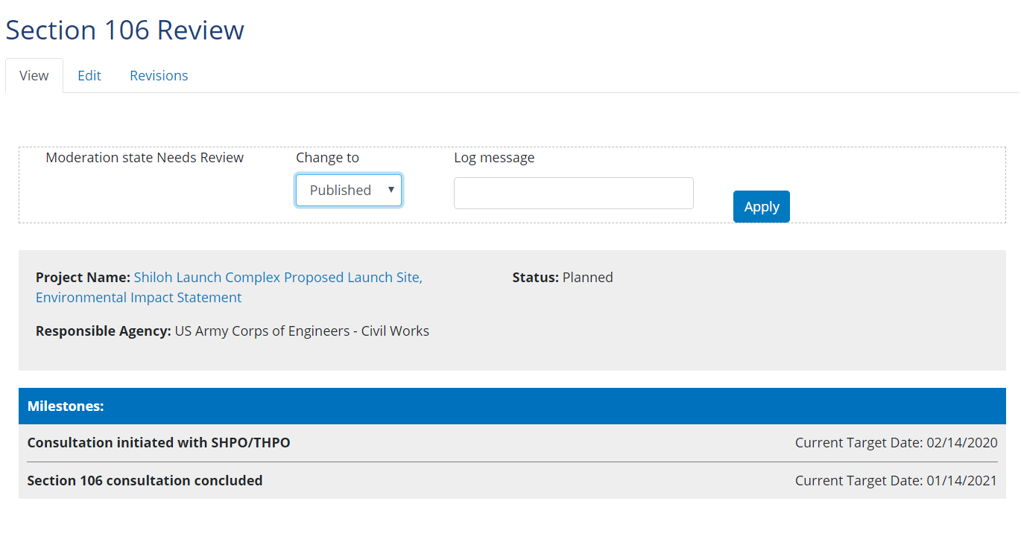

41

41

1. Once the Draft is placed in Needs Review, The Approver role can then move the Action page from **NEEDS REVIEW** to **PUBLISHED t**o publish the Action data to the public facing site.

You have now successfully created an Action for a Project and made the Action public facing!

### Editing an Action

To edit an action, log into the Dashboard and select the ‘My Action’ tab. The Actions tab is an easy way to find a specific Action within a Project.

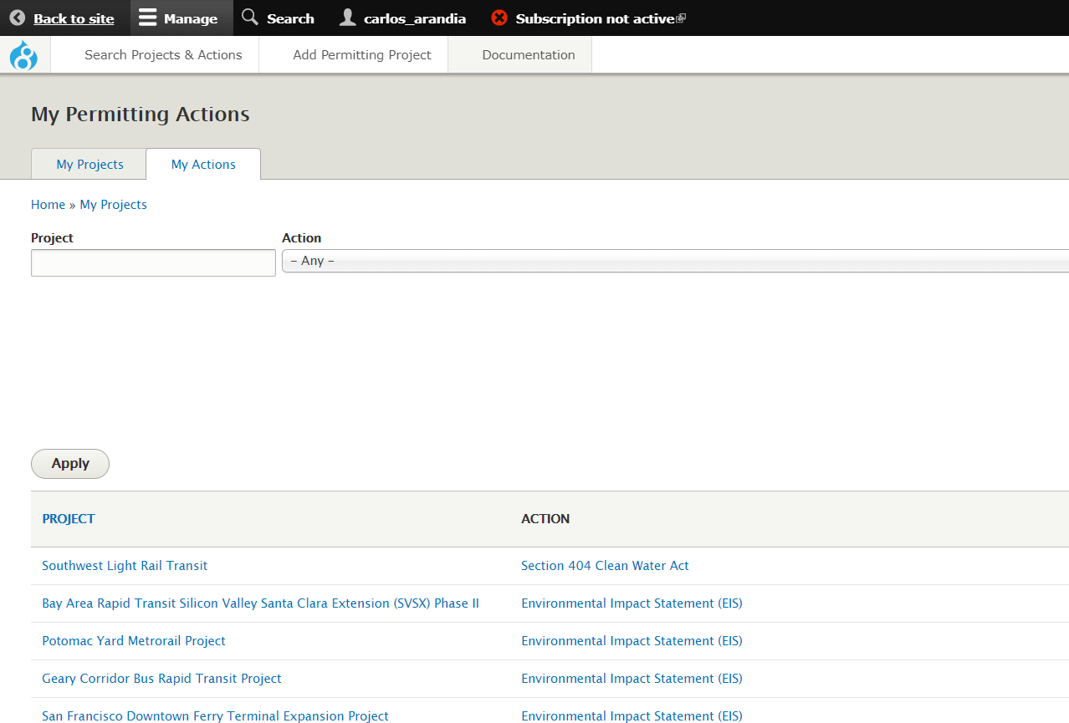

11

1. See the screenshot above which indicates the ‘Actions’ tab.

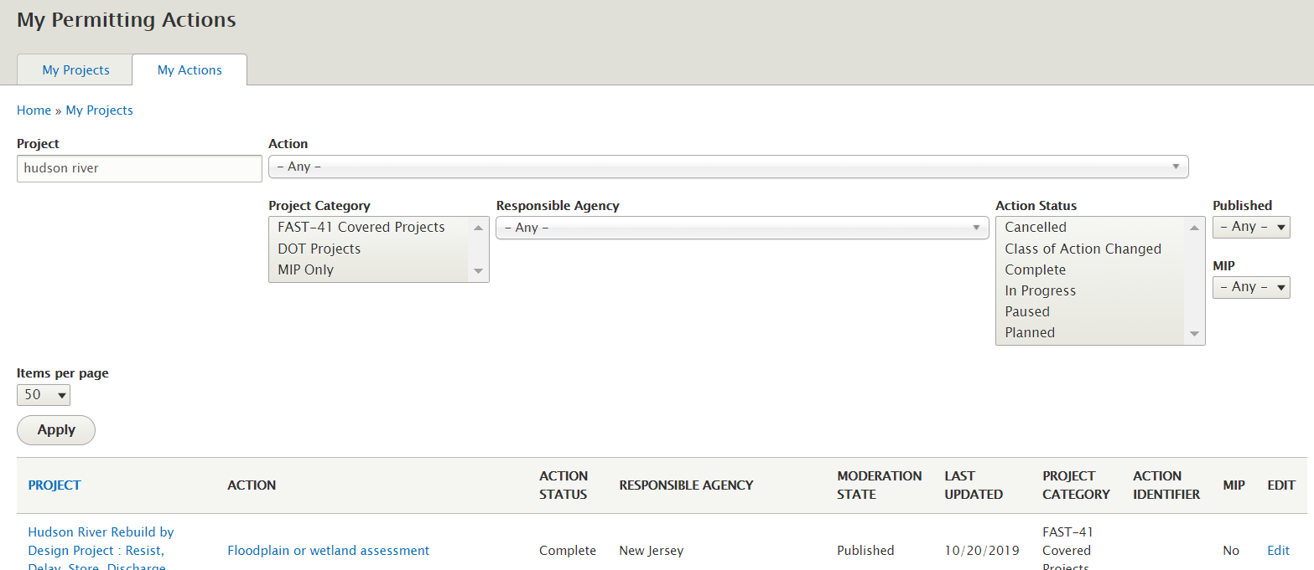

21

11

11

1. Once on the Actions tab, type the Project for which you’d like to view the Actions for in the ‘Project Name’ field. In the example above, Hudson River has been typed within the Project field. Once ‘Apply’ is selected, only Actions for the Hudson River project will display.
2. Locate the Action which you would like to Edit. In this scenario above, the Floodplain or wetland assessment Action is the Action that needs to be edited. I will locate the Action and select the ‘Edit’ link from the Operations column.

NOTE: Once you select the Edit button, this will take you the Action’s form where you can edit the information entered from section 4.6.1.

### Adding Additional Record of Decisions to an Environmental Impact Statement

In instances where an Environmental Impact Statement (EIS) has more than one Record of Decision (ROD) that needs to be applied, you can do this by completing the following steps:

1. Edit the EIS that you need to add the additional ROD(s) to
2. Once on the EIS edit form, go to the milestone table section where you edit the milestone dates
3. Notice you will see several “Additional Record of Decision” milestones marked as N/A by default

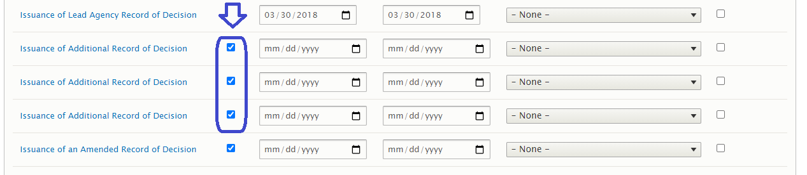

1. To apply additional RODs, uncheck the N/A checkbox for each Additional Record of Decision milestone that is needed. If it is just one Additional Record of Decision milestone that’s needed, then only one should be unchecked as N/A

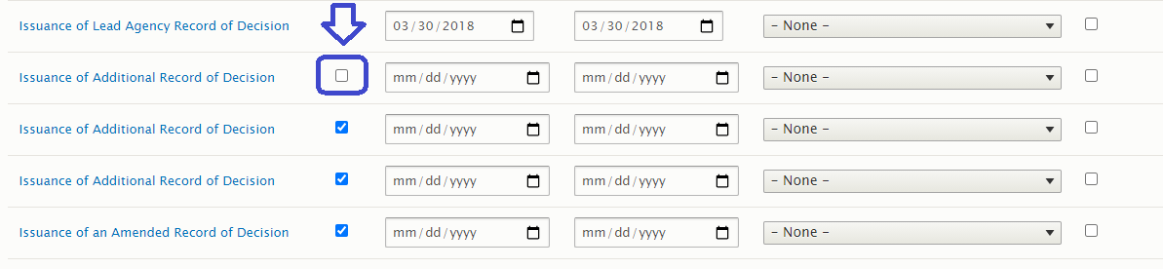

1. Ensure that you then add a Current Target Date for the Additional Record of Decision milestone

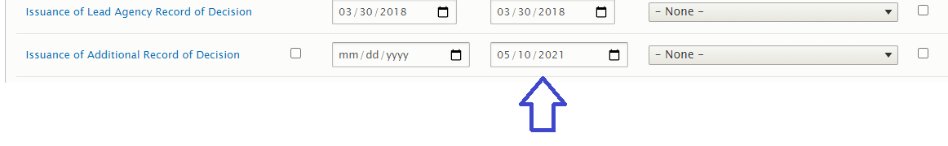

1. Click on the “Additional Record of Decision Milestone” to expand other fields below to add the agency Signatories

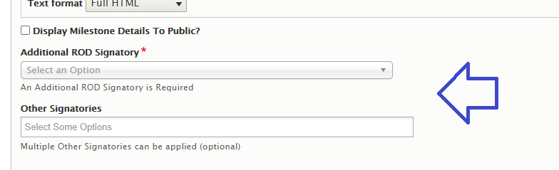

1. Once the agency Signatories are added to all the Additional Record of Decision milestones that you have applied, you can save the Action and move the Action through the workflow to get it published

### Setting Project Dependencies

You can set up dependencies between Actions within a project in the Timeline tab. The dependency fields are located at the bottom of the Timeline tab. Below is a demonstration of linking an Environmental Impact Statement to a Section 106 as a dependency.

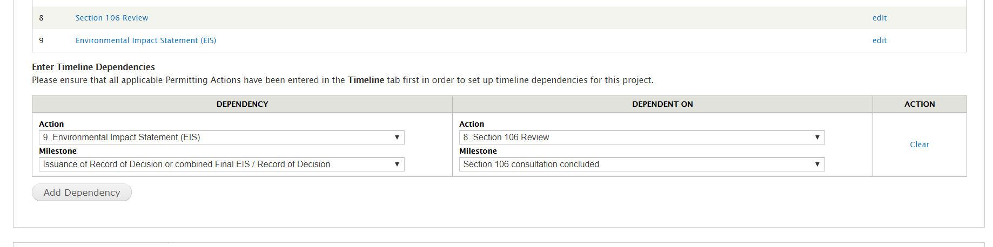

2

1

**NOTE:** You can only set up dependencies with existing Actions that you have for the project. Therefore, it is best to add all applicable Actions for the project first in order to have a full list of dependencies to set up.

1. To continue to add more dependencies, select the ‘Add dependency button’
2. To remove a dependency, select the ‘Clear’ link.

As always, any changes made must be published through the Draft -> Needs Review -> Published workflow. For project dependencies, the ‘project’ page will need to go through the workflow for the de

# Section 408 Permit

Please note: When select any Agency Action from the Milestones table and changing the dates system will generate a validation message.

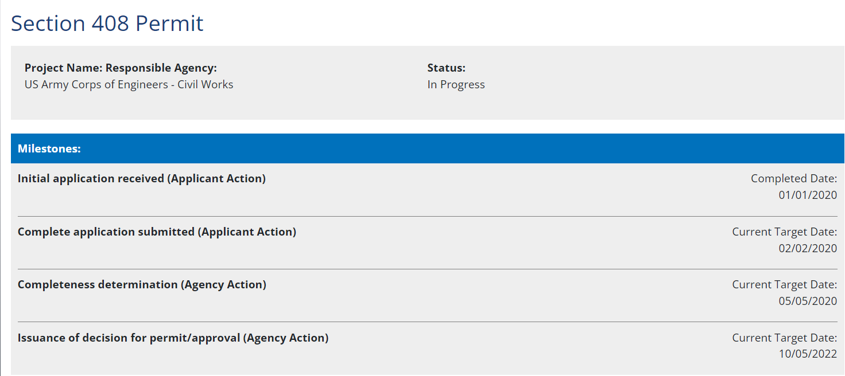

# Project Workflow

Within the Permitting Dashboard Data Entry Application there are two workflows that dictate what is published to the public website. There is a workflow to publish the high-level project information, and another workflow to publish each individual Action within the Timeline tab.

## Publishing General Project Information

Publishing a project will push all updated content within the General Information, Location, Organizations and Outcomes tabs to the public website. Publishing a project WILL NOT publish your Actions within the project. However, publishing the project will publish any project dependencies that have been set up within the Timeline tab.

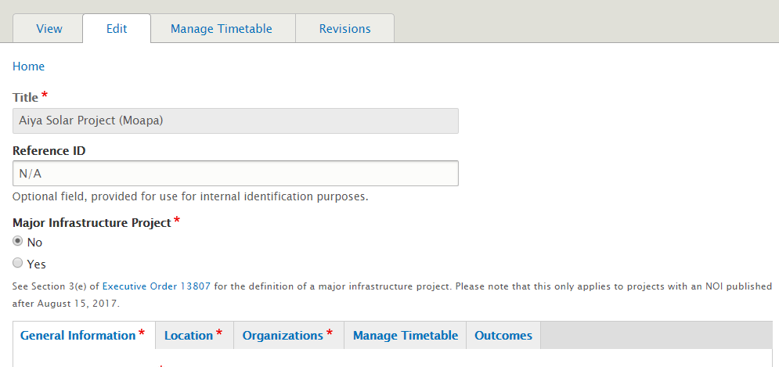

1. These four tabs have information pushed to the public site when a project is published

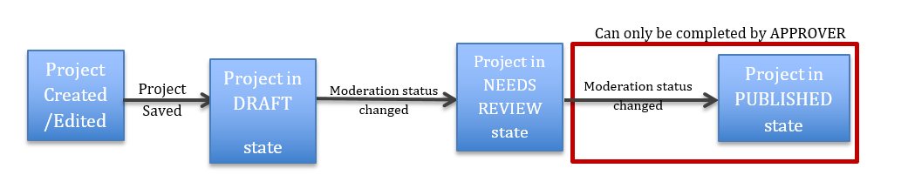

When a project *AUTHOR* creates, or edits a project, that information is saved in a **DRAFT** state. Projects will remain in **DRAFT** until an *AUTHOR* sets the status to **NEEDS REVIEW**; at which point they should manually/orally inform a project *APPROVER* (For FAST-41 projects, the Executive Director can only publish project and action data) that the project is ready for review and publication to the public-facing website.

Only the *APPROVER* role (or Executive Director role for FAST-41 projects) can move a project’s status to the **PUBLISHED** status.

Note: The project must go through all stages (including NEEDS REVIEW) in order to publish correctly on the public-facing website.

# Public Website View

## Viewing / Searching for Projects

All Projects in the Permitting Dashboard can be viewed by accessing the following link: <https://www.permits.performance.gov/projects>. The page will display as seen below

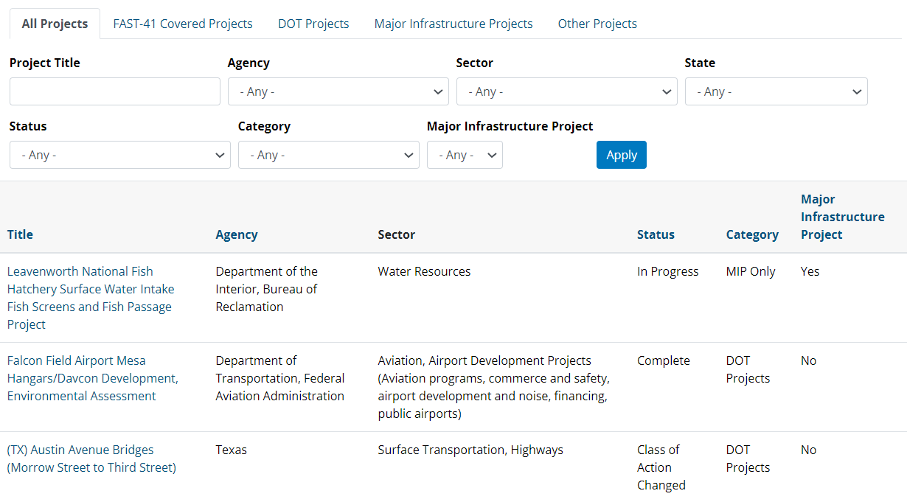

Notice that the data table has separate Tabs that separate projects by their Classification:

* All Projects
* Fast-41 Covered Projects
* DOT Projects
* Major Infrastructure Projects
* Other Projects

Once you are in a given tab, Projects can be further filtered by:

* Project Title
* Lead Agency
* Sector
* State
* Status
* Major Infrastructure Project or Project Category

## Download or Export of Project Data

Project Data can be downloaded into an Excel sheet.

* 1. To download project data, please use the Permitting Dashboard Data Portal: <https://data.permits.performance.gov>

## Project Map Data

Published projects’ location information can be viewed on an Interactive Map located on the homepage of the Permitting Dashboard website. You may view the map on the homepage of the dashboard at <https://www.permits.performance.gov/>

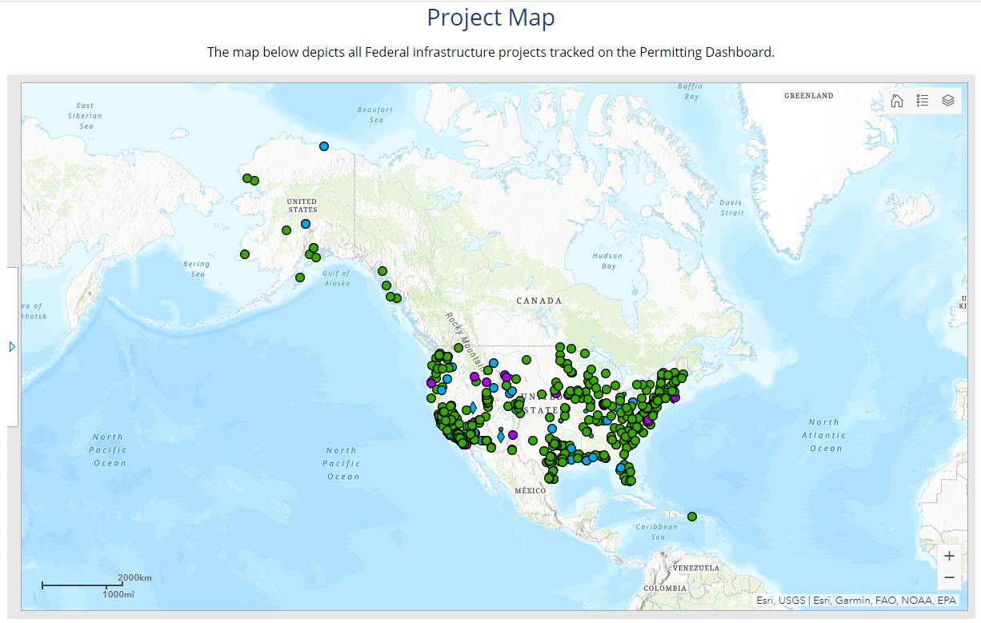

21

11

Once on the interactive map page, several features will be available for use.

1. Clicking the dots on the map displays individual projects along with a summary of additional information for the project
2. Selecting the project title from the pop up directs you to the project page
3. Select to view and apply filters to the map such as project category and project sector

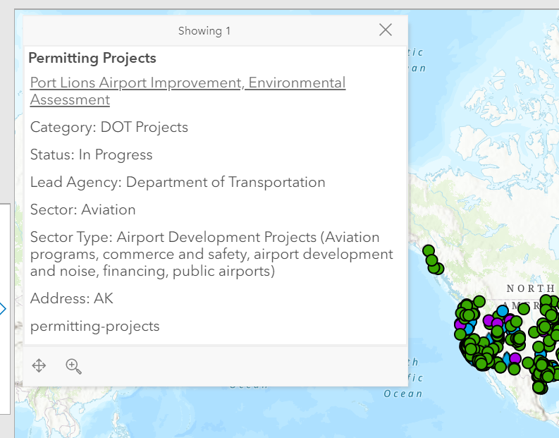

31

# Extending Dates into Executive Director Review on The Permitting Timetable

## Extending Dates into Executive Director Review as a Project Author or Approver

When any milestone’s Current Target Completion date within an Action is modified to a date that is greater than 30 days of the furthest out milestone Original Target Date, then the Action will be sent to the Executive Director for review, when the Action is moved from DRAFT to NEEDS REVIEW.

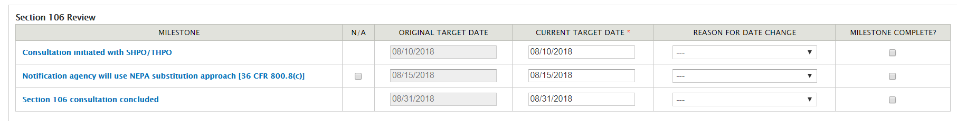

When the Action is prompted for Executive Director review, a text box will appear (as shown below). Use this text box to enter details and any additional information regarding the extension. The text entered in this box will be displayed to the Executive Director only and will not be displayed publicly and plays an important part in the Executive Director’s decision to acknowledge the extension.

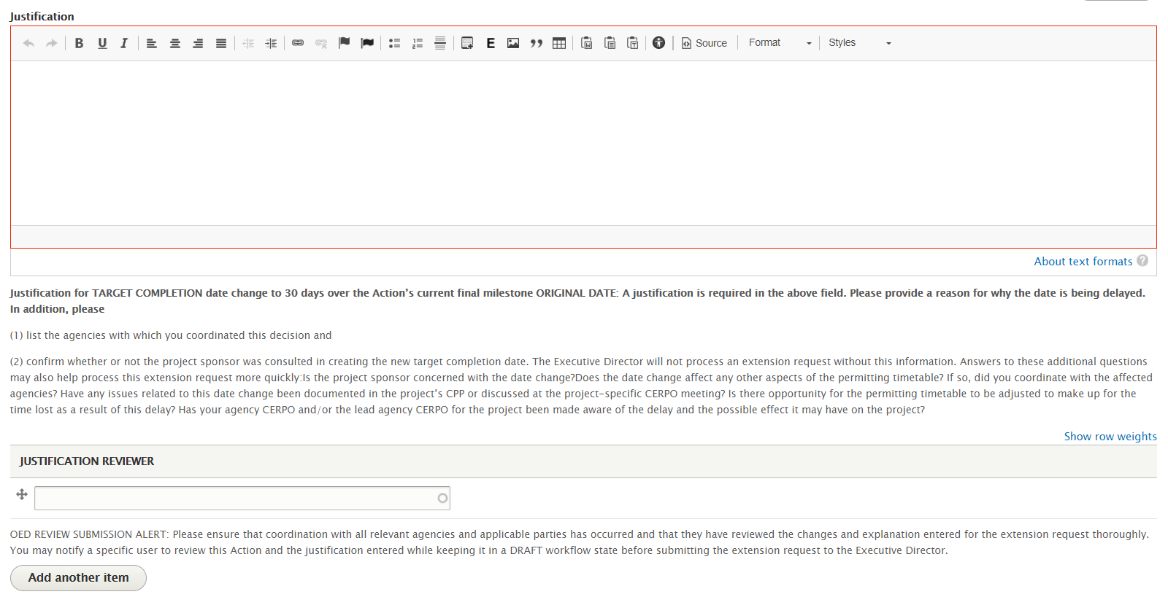

11

1. You may search through permitting dashboard users to select to alert via an email notification to review the explanation entered for the extension. If choosing the have someone review the explanation entered, you must Save and keep this Action in the “DRAFT” moderation state. As soon as this Action is moved to “Needs Review” it will be locked for Executive Director Review until the extensions is accepted or rejected

Once the Executive Director approves/acknowledges the extension, the Action will be moved to the “NEEDS REVIEW” revision state where an Approver may then PUBLISH the Action.

# FAST-41 Missed Dates Process

1. **For FAST-41 projects only:** An agency user extends a Permitting Action’s final required milestone target date within 30 days of the existing target date or a target date has passed by 5 business days triggering a “Missed Date”



1. The Executive Director role is notified of the missed date and can view it on the Pending Tasks page underneath the **Missed Date Pending Tasks** tab

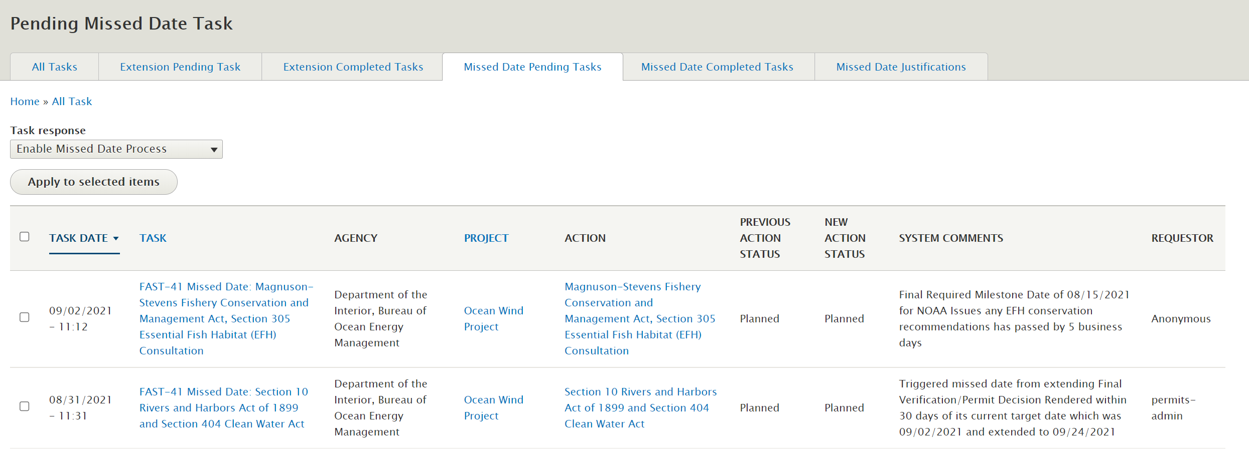

1. From this tab, the Executive Director can view the missed date and choose to either
   1. **Enable the Missed Dates Process** - after choosing this option, the Executive Director will be prompted to enter comments on this case – this will not be visible to the public.

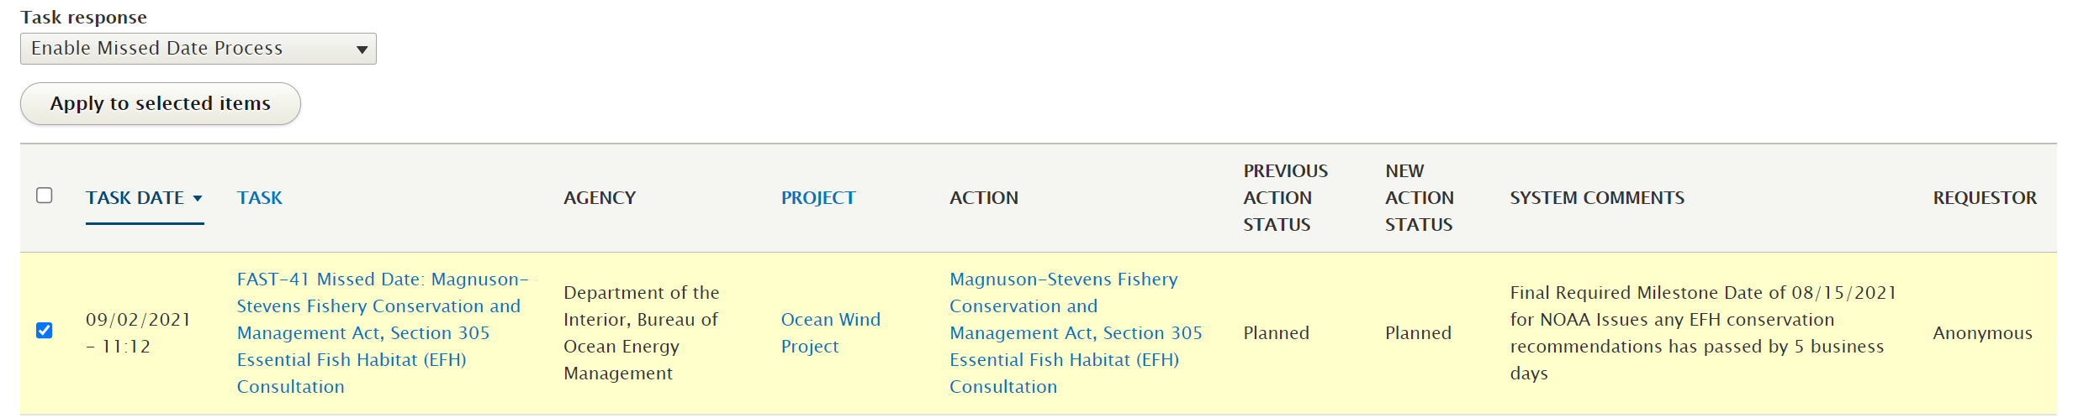

* 1. **Exempt the Agency User of The Process** - exempting an action from the missed dates process effectively ends the missed dates process for this action. After choosing this option, the executive director will be prompted to enter comments – this will not be visible to the public

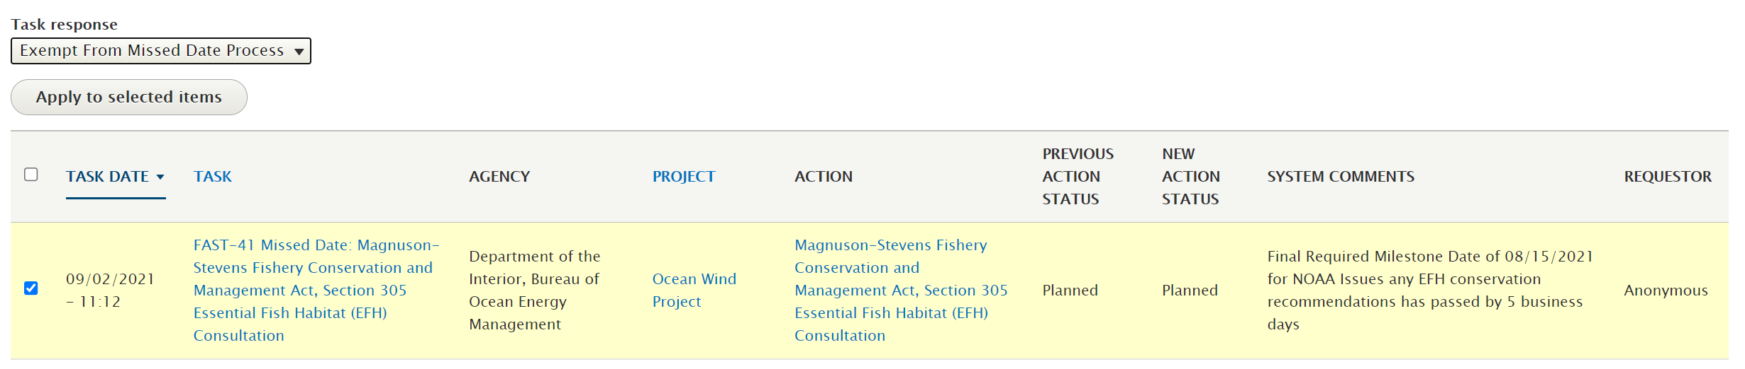

1. Upon enabling the process, the agency user will be required to submit monthly justifications and users within the Dashboard Admin agency role of the Responsible Agency for the Action will get an email notification once the process is enabled
2. 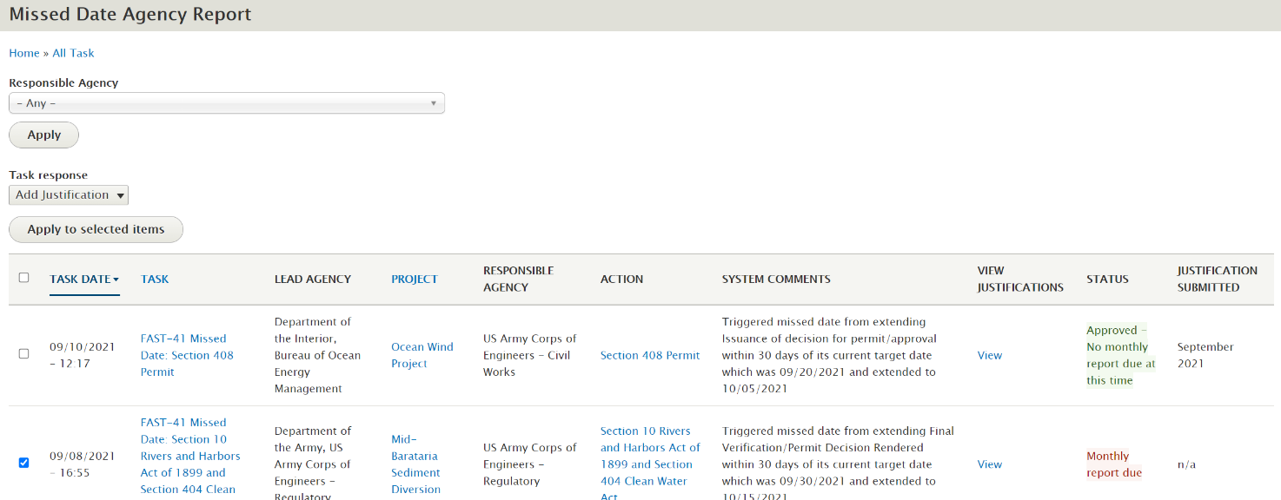The agency user should navigate to the **FAST-41 Missed Date Monthly Reports** tab, check the permit they would like to submit a justification for, and choose ‘apply to selected items’
3. The agency user can set the month and year they are submitting a justification for, enter the justification, and choose ‘add justification’

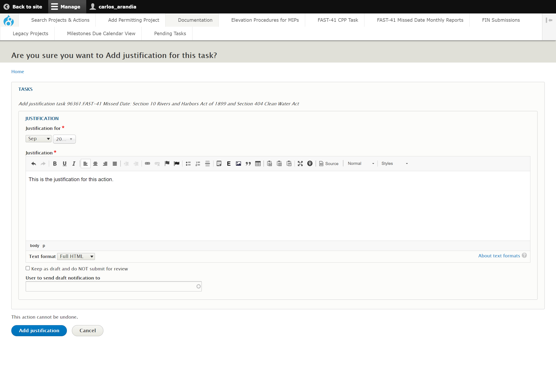

1. Once a justification is entered, select the blue button “Add Justification” which will notify the Executive Director of the justification for review.
2. Once the Executive Director is notified of the newly added justification, the Executive Director can access 🡪 **Pending Tasks, Missed Date Justifications** tab as seen below. The executive director can either
   1. 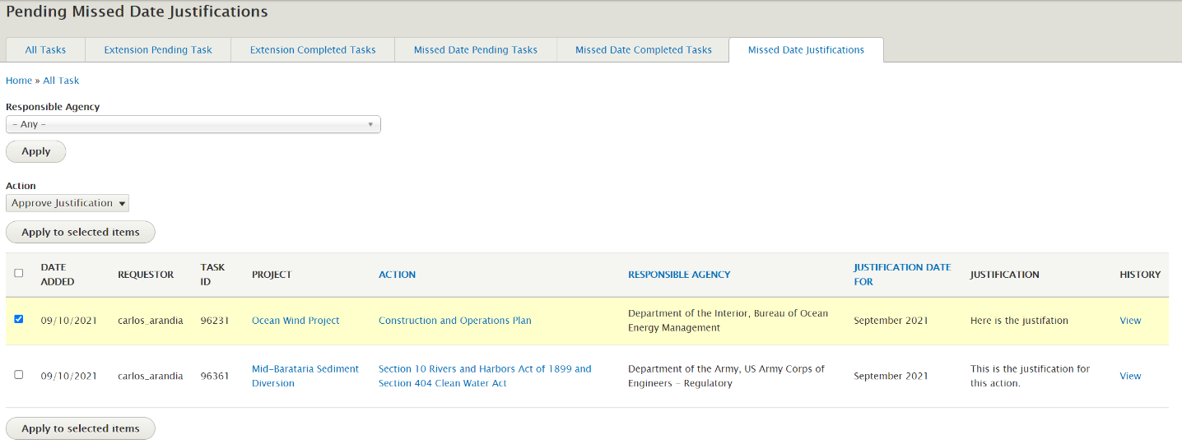**Approve the justification** and enter any associated comments. If a justification is approved, the agency user’s task for the month will be completed and will not need to submit a justification until the following month. The approved justification will also display on the Action page, which is visible to the public.
   2. **Reject the justification,** and enter any associated comments
3. If a report is rejected by an executive director, an agency user must re-submit their monthly report, from the **FAST-41 Missed Date Monthly Reports** tab, until it is approved by the Executive Director.

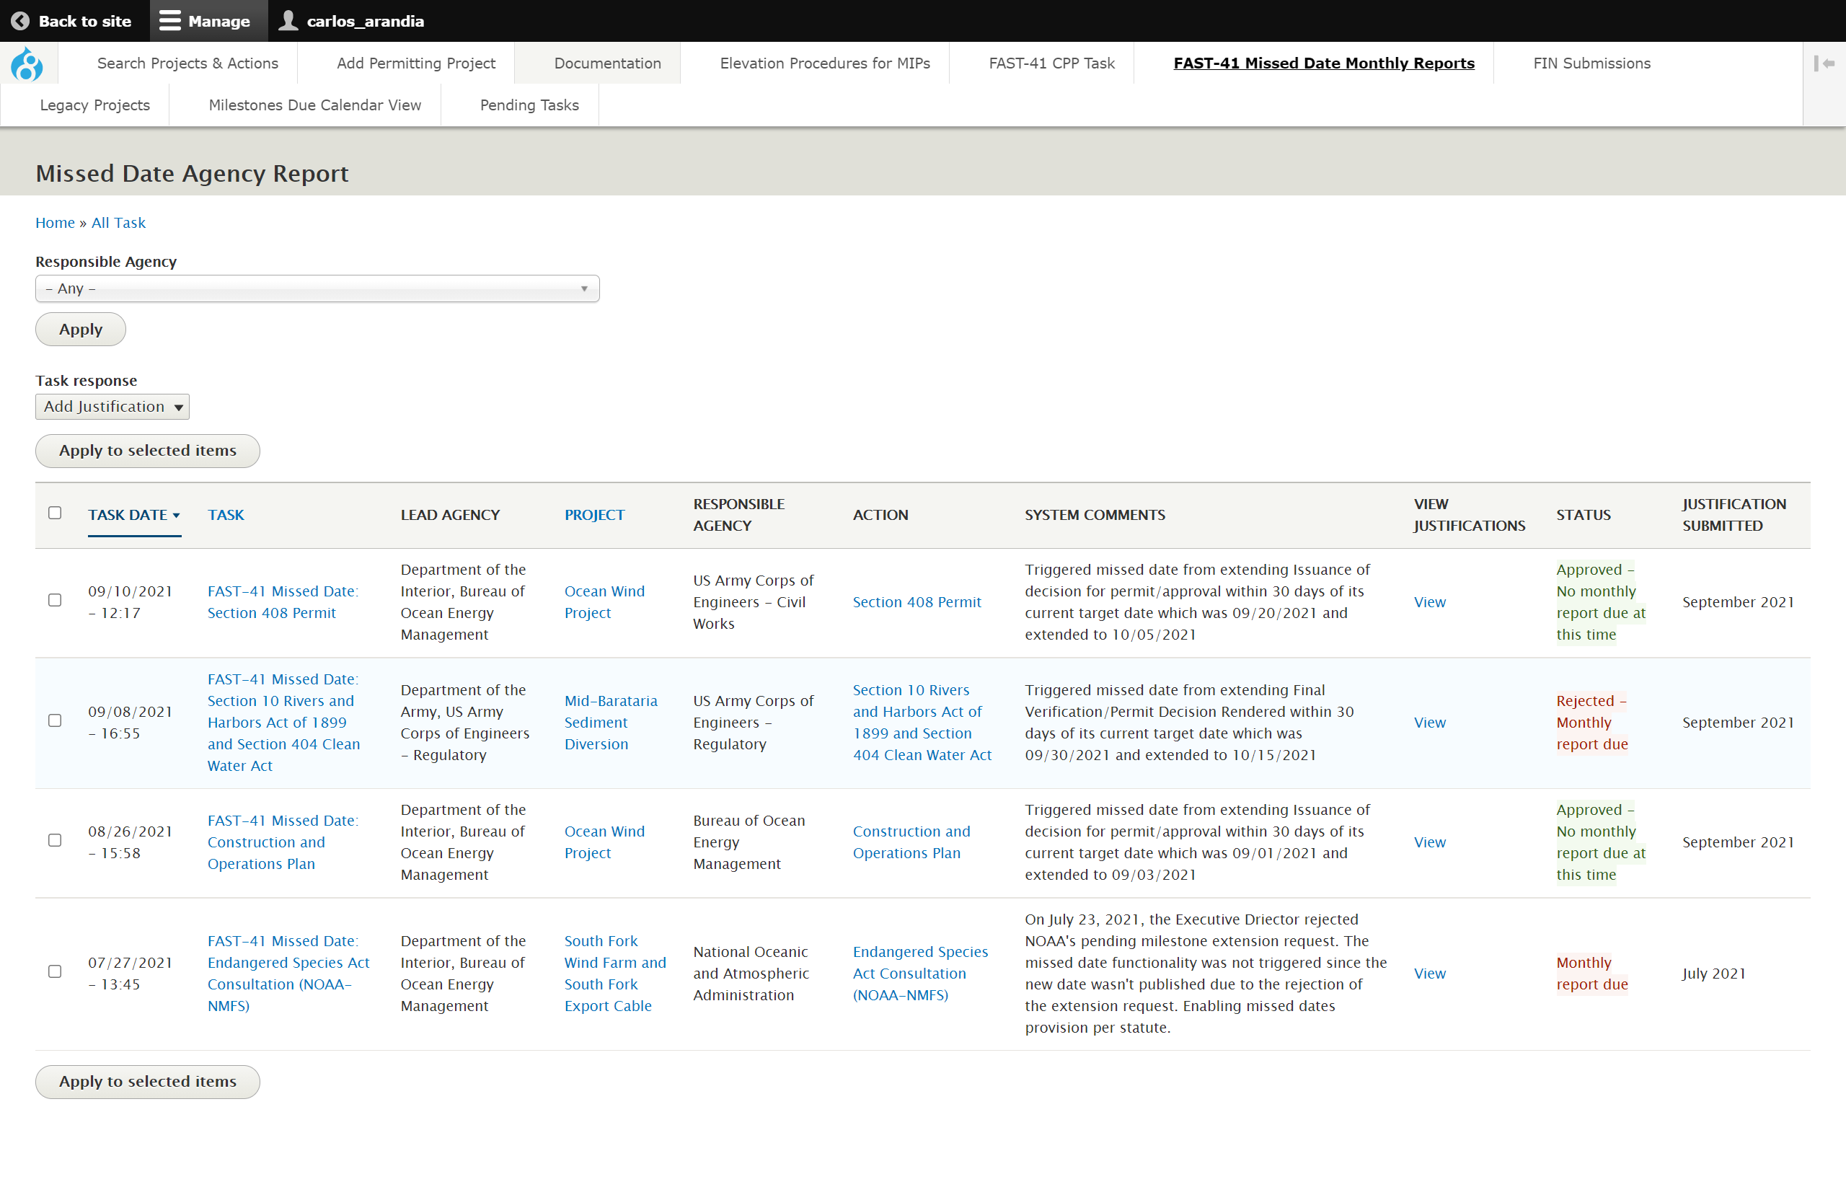

# Major Infrastructure Projects: One Federal Decision

If your project is a Major Infrastructure Project, then you will need to indicate whether the project is being processed in accordance with the One Federal Decision framework. See below for instructions on how to complete the One Federal Decision task.

1. Log onto the Dashboard and search for the specific project. In the example below, I will locate the ‘Jordan Cove’ project. Ensure once the project name is typed in you select “Apply” to apply the filter

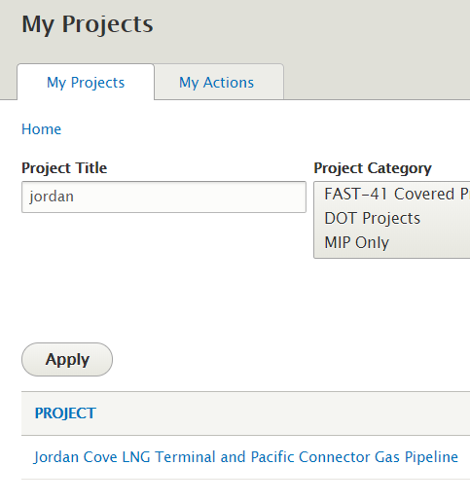

21

11

1. Select the project link

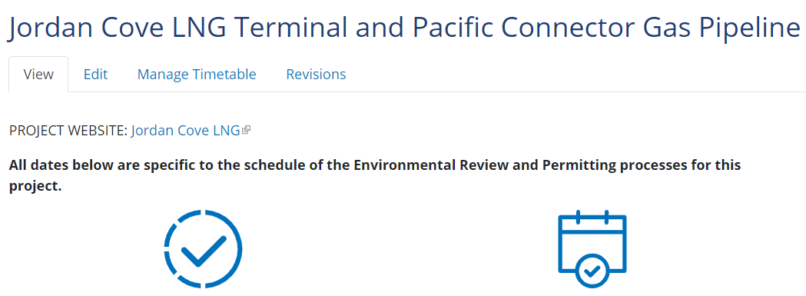

31

1. Once on the project page, select ‘Edit’
2. Once you are on the project’s data entry form, ensure that the Major Infrastructure Project button is selected as ‘Yes’

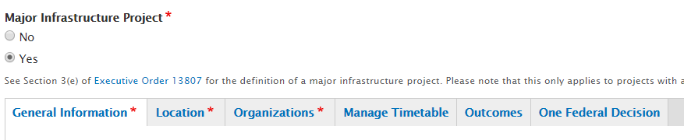

51

41

1. Once ‘Yes’ is selected, notice that the ‘One Federal Decision’ tab appears.

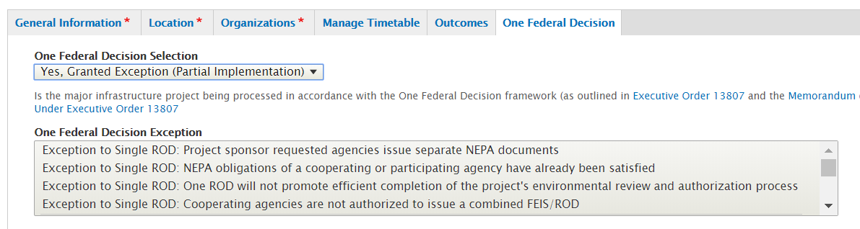

61

1. Notice within the One Federal Decision tab, you may indicate Yes, No, or No but granted an exception(s) for your Major Infrastructure Project’s One Federal Decision selection.
2. Once you have made a selection select the ‘Save’ button on the bottom of the page.



1. After selecting ‘Save’ you will be brought to view the project page where you must publish the project in order to make your One Federal Decision selection official. The Lead Agency of the project can move the project from DRAFT to NEEDS REVIEW. An Approver can then move the Project from NEEDS REVIEW to PUBLISHED.

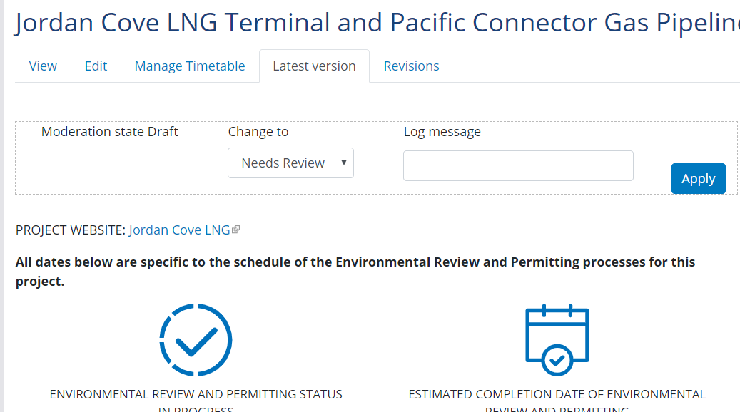

81

81

**NOTE:** You may edit the One Federal Decision selection for your project at any time by editing the project and making a different selection then publishing the project again.

**NOTE:** The selection made for the One Federal Decision framework is NOT public facing.

# Down-Scoping an Environmental Assessment (EA) or an Environmental Impact Statement (EIS) to a Categorical Exclusion (CE)

The following steps demonstrate how to indicate that an Environmental Assessment has been Down-scoped to a Categorical Exclusion on the Permitting Dashboard site.

1. Log on to the Permitting Dashboard
2. Select the Actions tab to search for a specific permitting action on the top right of the screen

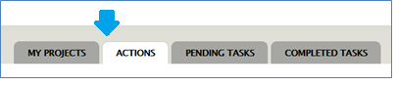

1. Set the filters to search for the specific permitting action that you want to indicate as down-scoped and select “apply”

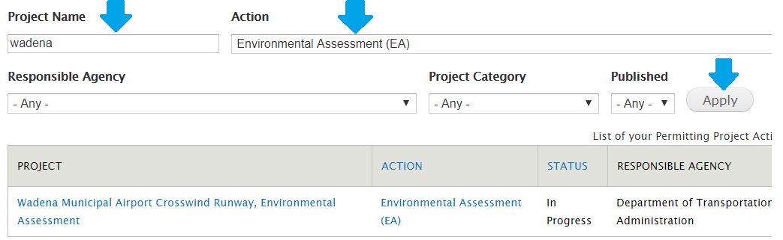

1. Once located, open the page by selecting the permitting action

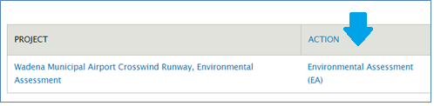

1. Select edit on the permitting action page

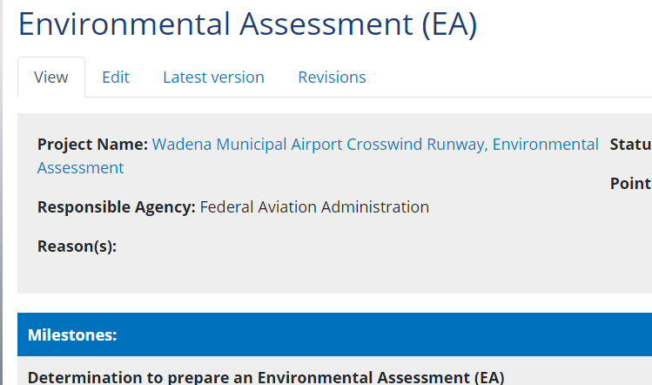

81

1. Locate the Status field and set it to Class of Action Changed

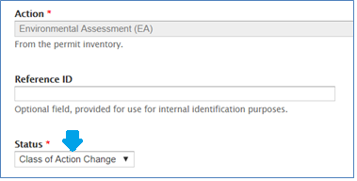

1. Locate the Action Outcome field and set it to Categorical Exclusion

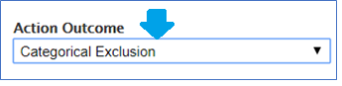

1. Make any other changes necessary to the permitting action
2. Once done, select “Save” at the bottom of the form

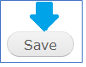

1. Once ready, move the permitting action through the workflow to publish the changes from Draft to Needs Review. Then an approver can publish the action by moving it from Needs Review to Published. *(NOTE: Ensure that the project status is also set to Class of Action Changed)*