

FAST-41 Permitting Dashboard

Data Entry Application User Guide

Last Updated: August 22, 2019

Training Topics:

1. Prerequisites 4

2. Accessing the Data Entry Application 5

3. My Permitting Projects – Workbench 6

4. Create or Edit a Project 7

4.1 General Information Tab 7

4.2 Electrical Transmission Checkbox 9

4.3 Location Tab 10

4.4 Organization Tab 12

4.5 Project Sponsor 13

4.6 Timeline Tab 13

4.6.1 Creating an Action 14

4.6.2 Editing an Action 23

4.6.3 Setting Project Dependencies 24

4.7 Outcomes Tab 25

4.8 One Federal Decision Tab 27

5. Project Workflow 27

5.1 Publishing High-level Project Information 27

6. Public Website View 29

6.1 Viewing / Searching for Projects 29

6.2 Download or Export of Project Data 29

6.3 Project Map Data 30

6.4 Environmental and Community Outcomes 31

7. Coordinated Project Plan Quarterly Certification (Dashboard Admins only) 33

8. Extending Dates into Executive Director Review on The Permitting Timetable 35

8.1 Extending Dates into Executive Director Review as a Project Author or Approver 35

8.2 Approving/Acknowledging Extensions as the Executive Director 36

9. Major Infrastructure Projects: One Federal Decision 37

10. Down-Scoping an Environmental Assessment (EA) or an Environmental Impact Statement (EIS) to a Categorical Exclusion (CE) 41

11. Indicating an Environmental Impact Statement (EIS) as re-classified to an Environmental Assessment (EA) 46

# Prerequisites

In order for a user to gain access to the Permits Data Entry application the user first must have access to the MAX.gov site (henceforth referred to as ‘MAX’). Self-registration is available to Federal government employees and contractors with a Federal government email address and can be registered by visiting <https://max.gov/maxportal/registrationForm.action>.

Federal employees/contractors with a non-government email address as well as non-federal employees performing Federal activities will need to contact a current federal government employee with a MAX account who will act as a sponsor for the non-federal user. The sponsor will need to contact the MAX.gov help desk at: **202-395-6860** or at the following email: [maxsupport@max.gov](mailto:maxsupport@max.gov) for further information on registering the non-federal user.

Once registered with MAX, the user should have their agency dashboard administrator contact: [carlos.arandia.ctr@dot.gov](mailto:carlos.arandia.ctr@dot.gov) and provide the following information:

1. The user’s name
2. The email address this individual used to register with MAX
3. The project(s) for which the user will need access
4. The desired access level, i.e.:

* **Read Only:** Ability to view projects
* **Author:** Ability to view, edit, and create projects
* **Approver:** Ability to view, edit, create, and publish projects for public view

Once the above steps are completed, and confirmed, the user will be able to login to the Permitting Dashboard Data Entry system to begin creating or editing their project information.

**User Permissions Note:**

Currently, each Agency’s **Dashboard Administrators** is responsible for identifying users from their agency and assisting them in gaining access to the Data Entry System to enter/edit project information relative to their given role (**Read Only, Author, Approver**).

As the Dashboard evolves, Dashboard Administrators may be responsible for limiting user access to specific projects.

This User Guide will be updated as new capabilities are implemented.

# Accessing the Data Entry Application

Google Chrome or Mozilla Firefox browsers are recommended to access the Permitting Data Entry Application.

To begin, enter <https://cms.permits.performance.gov/user> into your web browser to reach the MAX Login screen:

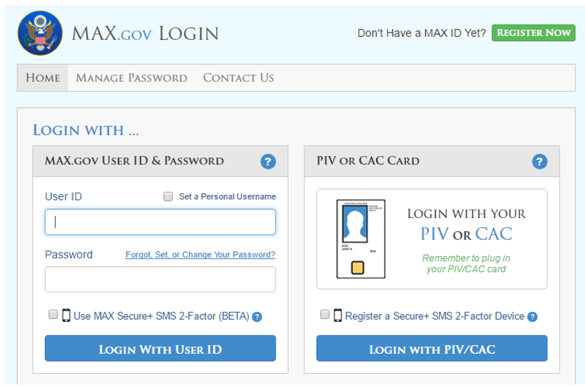

At the MAX login screen; enter your **User ID** and **Password**, and click LOGIN WITH USER ID to be directed to the Permitting Data Entry Application.

If you do not know your MAX Login information click the FORGOT, SET, or CHANGE YOUR PASSWORD link.

If you are not registered in the MAX system, click the REGISTER NOW box at the top right of the login screen.

# My Permitting Projects – Workbench

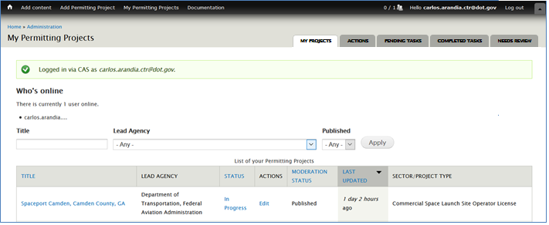Upon logging in to the Permitting Data Entry Application, you will first be presented with the **Workbench.** This is the ‘home page’ for interaction with your Permitting Project(s).

7

8

6

5

1

2

4

3

Key features (noted in orange) include:

1. **Add Permitting Project** – Creates a new project
2. **My Permitting Projects** – Click here to return to your workbench ‘home page’
3. **Search / Filter** – Use this field to search by Project Title, or filter by Lead Agency
4. **Edit** – Click **Edit** in the **ACTIONS** column to update Project information
5. **My Projects** – Click here to view a table that allows you to view sort and filter all Projects
6. **Actions (tab)** -Click here to view a table that allows you to view sort and filter all Actions within Projects
7. **Pending Tasks** – Click here to view any tasks that may require your attention. Currently, this tab contains:
   1. quarterly acknowledgement from Dashboard Administrators to mark their Project’s Coordinated Project Plan as reviewed or updated
   2. Timeline extensions that require Executive Director Review
   3. Indicating if Elevation Procedures were used for milestone extensions for the Responsible Agency of the Action (OMB EO 13807 Requirement)
8. **Completed Tasks –** All items that are marked as complete from the Pending Tasks tab will move over to the Completed Tasks tab. Once a task is in the Completed Tasks tab, no further action is required for the task.

# Create or Edit a Project

The following section outlines the process used to create a Permitting Project –or- to edit an *existing* Permitting Project.

## General Information Tab

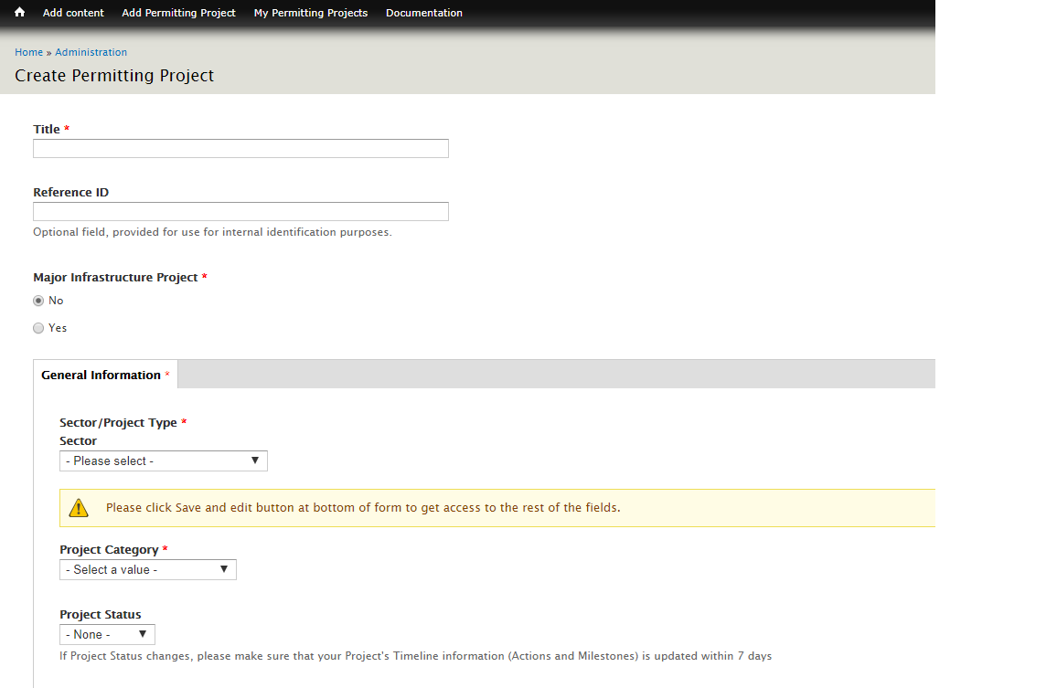

**6**

**5**

**4**

**3**

**2**

**1**

To create a new project, a few fields are system-required:

1. **Title \*** – Enter the title for your project
2. **Reference ID** – This is an optional field that can be used to tie back to the agency’s system
3. **Major Infrastructure Project \*** – Indicate whether the project which is being created/edited is a Major Infrastructure Project.
4. **Sector / Project Type \*** – Select the Sector of the Project. Once you choose a Sector, a list of potential associated Sector Types will be available for selection in the second field. Make a selection in both fields before proceeding
5. **Project Category \*** – Select from: FAST-41 Covered Project, DOT Project, or MIP-Only Project. This selection will enable sorting the [projects by tab](https://www.permits.performance.gov/projects) on the front-end display (Public website)
6. **Project Status** – Select from PLANNED, IN PROGRESS, PAUSED, COMPLETE, or CANCELLED

**\*** Indicates a required field

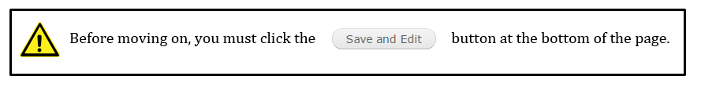After clicking ‘Save and Edit’, additional General Information fields become available along with several other tabs. Projects with ‘Electricity Transmission’ as the SECTOR will have additional fields displayed.

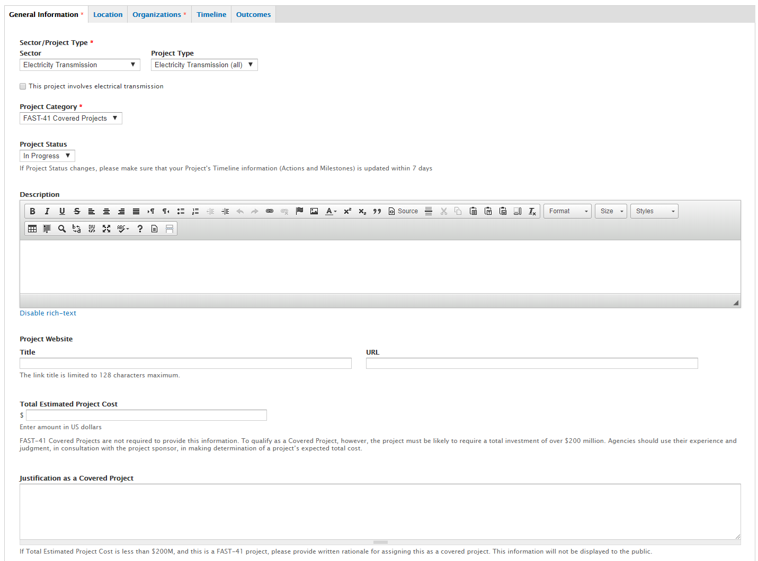

**6**

**1**

**5**

**4**

**3**

**2**

**Notes on the General Tab:**

1. **Electricity Transmission Projects** – Transmission projects, look for this checkbox below the description field. This box **must be checked** in order to reveal the additional Electricity Transmission project fields.
2. **Project Status –** If the project status is set to **Paused**, then you will be required to enter:
   1. The effective start date of the pause
      1. Users are required to enter an effective pause end date once the project is resumed
   2. An explanation for the start of the pause
      1. Users are required to enter an explanation for the ending of the pause status once the project is resumed
   3. A reason for the pause from only one of the following selections:

* Local Government Factors
* State Government Factors
* Tribal Government Factors
* Natural Disasters
* Pending Legal Action
* Project Sponsor Factors

1. **Description –** Enter information regarding the Project
2. **Project Website –** Enter the project’s website (if applicable)
3. **Total Estimated Project Cost –** This field is not required for FAST-41 Projects. DOT projects should enter this information. The cost will display on the front-end if entered. *This field accepts only numbers, no other symbols or text.*
4. **Justification as a Covered Project –** Populate this field if the project cost is identified as under $200M, according to directions in the Help Text. This field is for FAST-41 project only.

## Electrical Transmission Checkbox

If the ‘This project involves electrical transmission’ (#1) checkbox is selected, additional fields will display as listed below.

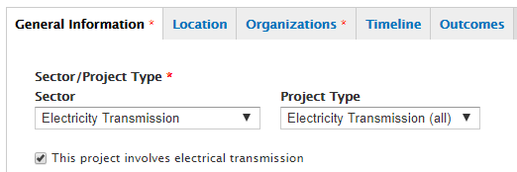

**1**

Additional Electricity Transmission fields include:

* 216(h) Qualification checkbox
* Voltage
* Number of Circuits
* Current Type
* Circuit Type
* Approximate Length
* Point of Origin: City, State, Substation
* Point of Terminus: City, State, Substation
* Proposed in Service Date

## Location Tab

The location tab allows entry of multiple locations for each project, if desired. You may enter as many locations as applicable, using Street Address, Lat/Long coordinates, or a combination of the two formats.

Only the location that is marked as ‘Project Primary Address’ will appear on the project map on the public website.

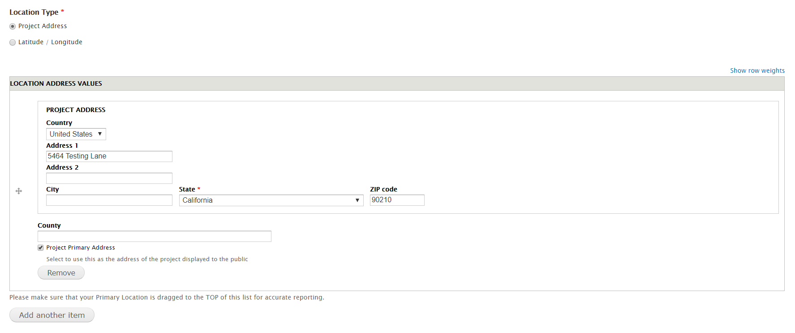

**1a**

**2**

**1**

1. **Location Type –** The location type radio buttons are used to select how you would like to enter a location for the project (by physical address or by latitude/longitude).
   1. A State must be entered for a project’s location.
2. **Project Primary Address** – This checkbox will set the above address as the project’s primary location, and will display under the Location section on the project page and the map.

**Latitude/Longitude**

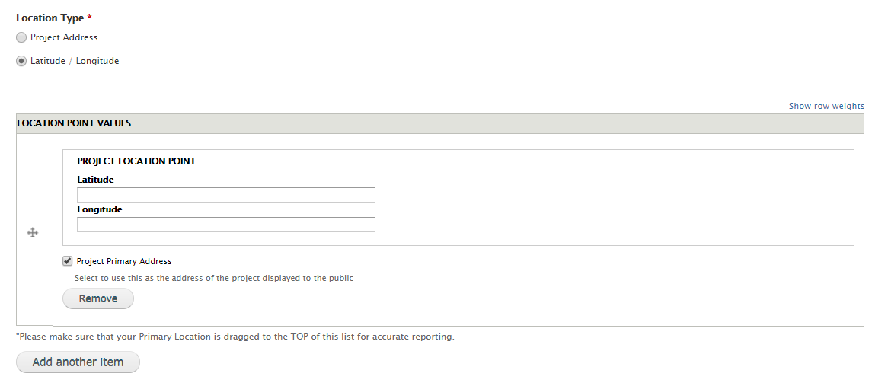

**1**

**2**

1. **Location Type –** The location type radio buttons are used to select how you would like to enter a location for the project (by physical address or by latitude/longitude).
2. **Project Primary Address** – This checkbox will set the above coordinates as the project’s primary location and will display under the Location section on the project page.

## Organization Tab

The Organizations Tab is used to capture parties involved in the Project’s permitting process, including the lead agency and project sponsors. Please populate as much information as possible to maximize transparency and accountability in the Permitting process.

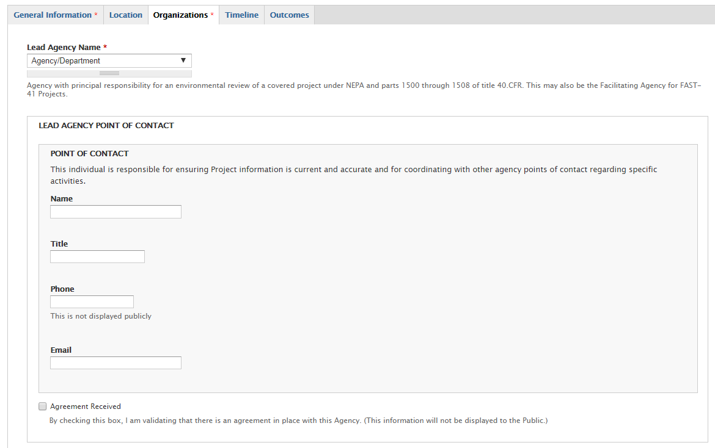

**3**

**2**

**1**

1. **Lead Agency and Bureau/Mode** – After selecting a Lead Agency, a second field will appear with the appropriate Bureau/Mode of choice
2. **Lead Agency Point of Contact** – Enter the applicable Lead Agency point of contact information
3. **Agreement Received** – This field is available for the Lead Agency and Project Sponsor fields. Check this box to track whether or not an agreement has been received from the organization.

## Project Sponsor

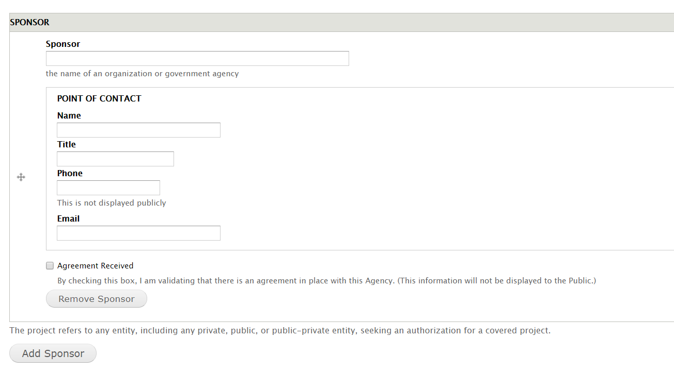

**1**

1. **Project Sponsor** – Enter the applicable project sponsor point of contact for the project
2. **Agreement Received** – This field is available for the Lead Agency and Project Sponsor fields. Check this box to track whether or not an agreement has been received from the organization

## Timeline Tab

The Timeline tab is where Permitting Projects’ Timeline information will be created and updated.

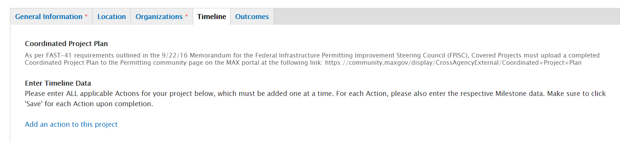

**2**

**1**

ACTION is an umbrella term used to include Permits, Abbreviated Reviews, and Authorizations.

1. **Coordinated Project Plan** – Per FAST-41 legislation, all Covered Projects must upload a completed Coordinated Project Plan to the Permitting community page on the MAX portal at the following link: <https://community.max.gov/x/NoGPQw> no later than 60 days after the project has been posted to the Dashboard.
2. **Add an Action to this Project** – Select this link to add each ACTION for your Project

Upon clicking on the Add an Action link, if you have unsaved information in any of the tabs, you will be prompted to save your project before creating another.

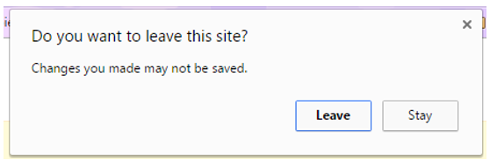

To save the project data, select ‘Stay’ then select ‘Save and Edit’ at the bottom of the form. After saving, when you click on the Add an Action link again, you will be directed to the **Create Permitting Action** page.

### Creating an Action

From the ‘Timeline Tab’, select the ‘Add an Action to this project’ link

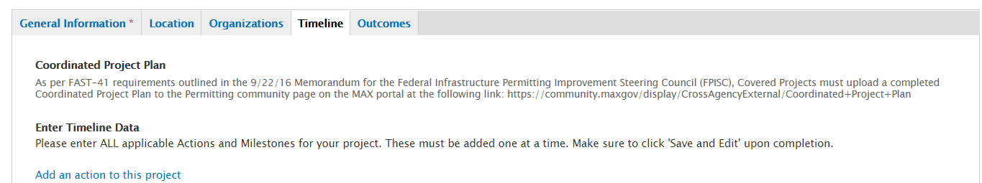

Once selected, you will be taken to the Permitting Action form as shown below

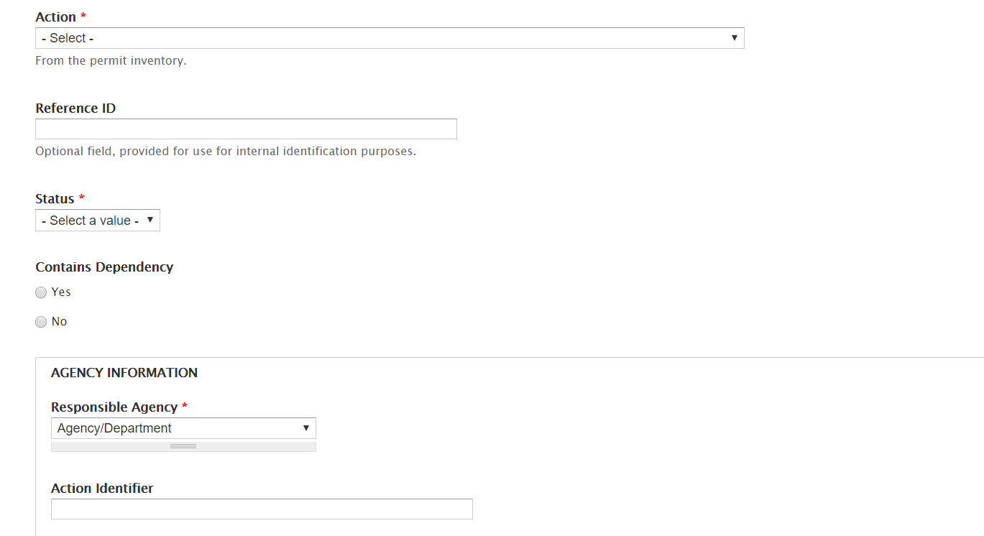

**6**

**5**

**4**

**3**

**2**

**1**

1. **Action** – A pre-populated set of Actions will appear in this dropdown (Section 106, EIS, EA, Section 404 Clean Water Act etc.)
2. **Reference ID** – This is an optional field that can be used to tie back to the agency’s system and is not public facing.
3. **Status** – Select the Action’s status. If “paused” is selected, several checkboxes will appear that will allow you to select a primary reason for the paused status. The reasons are as follows:
   1. Local Government Factors
   2. State Government Factors
   3. Tribal Government Factors
   4. Natural Disasters
   5. Project Sponsor Factors
4. **Contains Dependency** – Allows you to indicate whether the Action contains a dependency to another Action within the project.
5. **Responsible Agency** – Indicate the Agency that is responsible for the Action.
6. **Action Identifier** – Allows the ability to enter a phrase that would uniquely identify the Action such as entering the district or region of the Action.

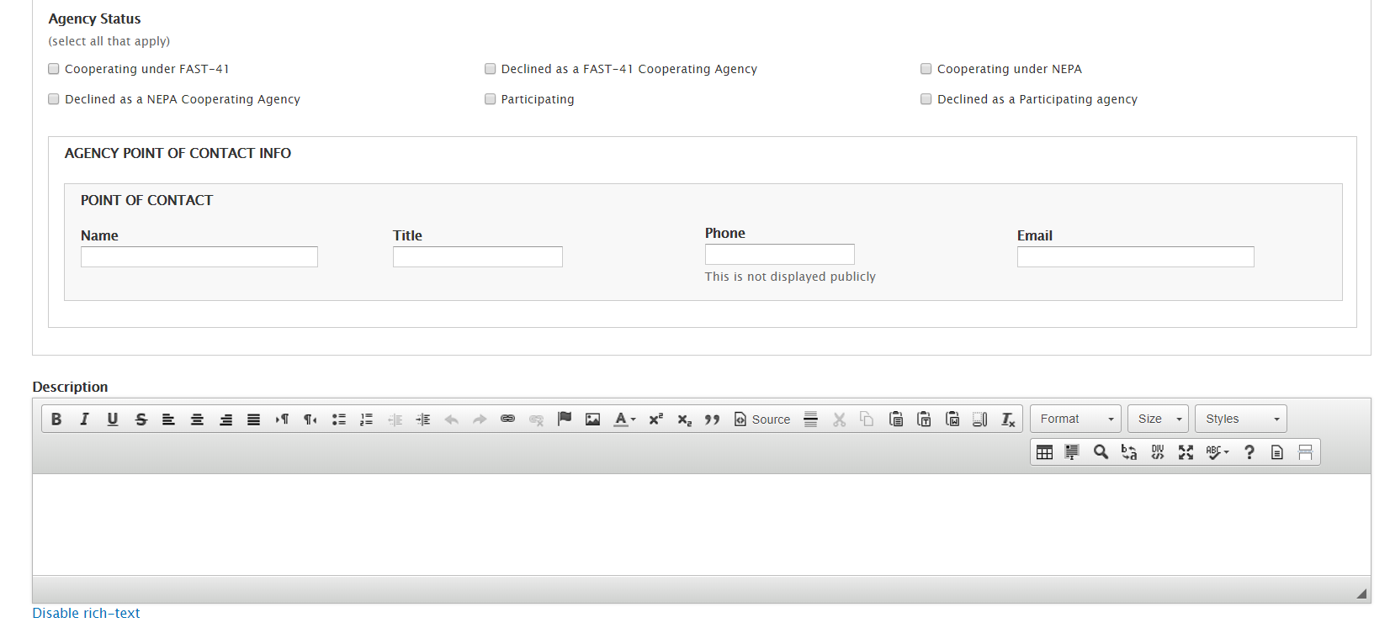

**9**

**8**

**7**

1. **Agency Status –** If Declined as a NEPA Cooperating Agency or Declined as a Participating Agency is selected then additional check box options display
2. **Agency Point of Contact Info –** Indicate the Responsible Agency point of contact information. Phone numbers are not be publicly displayed.
3. **Description –** Add any information that you may deem necessary and beneficial for the public to know about the Action.

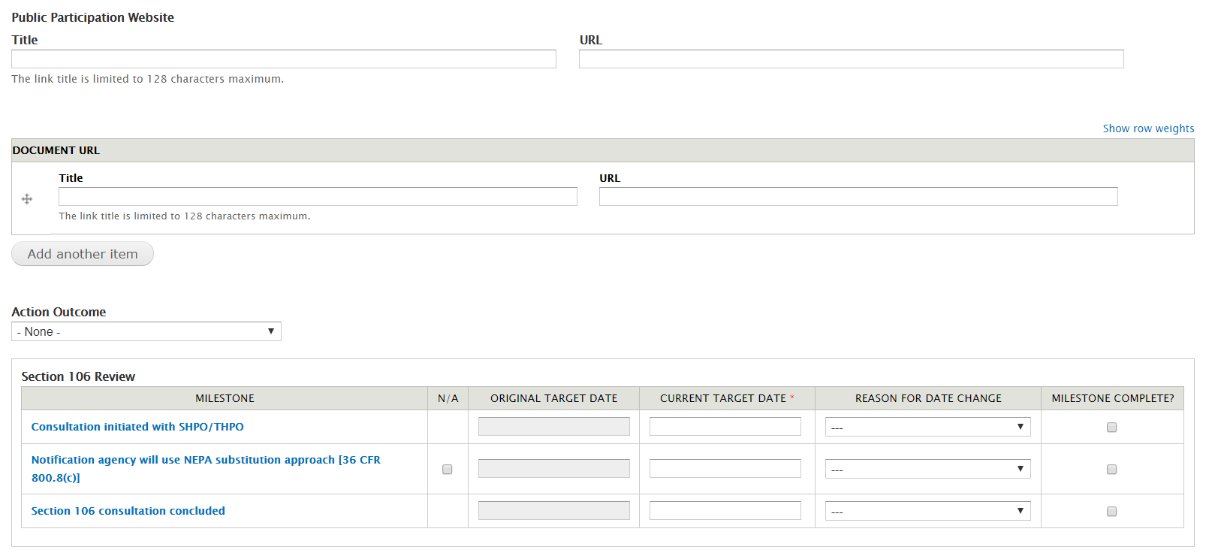

**13**

**12**

**11**

**10**

1. **Public Participation Website** **–** Enter the Public Participation Website for the Action if applicable.
2. **Document URL** **–** Enter any documents that are related to the Action if applicable.
3. **Action Outcome –** A selection for the Action Outcome field is currently only needed for two Actions, Section 106 and the Endangered Species Act Actions. A selection is required when the final milestone is marked as ‘completed’ for the Section 106 and the Endangered Species Act Action.
4. **Milestones** 
   1. **N/A:** Allows you to indicate whether the milestone is not applicable to the Action.
   2. **Original Target Date:** This field will automatically populate with the ‘Current Target Date’ entered for each milestone once the Action’s status is published as ‘In Progress.’ The Original Target Date serves as a field to view the initial target date entered for the milestone during the permitting process.
   3. **Current Target Date:** Enter the Current Target Date for each milestone.
   4. **Reason for Date Change:** Allows you to indicate from a pre-populated list of reasons for why a milestone’s Current Target Date has been updated. A Reason is only required for a milestone if the milestone’s date has been updated.
   5. **Milestone Complete?** Allows you to indicate when a milestone is completed. Milestones can’t be marked as completed with a future target date entered.

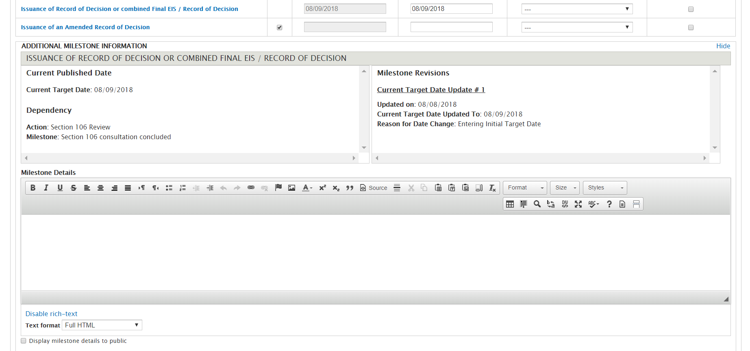

**15**

**14**

1. **Additional Milestone Information** **–** Selecting a milestone will open a section below where you can view the milestone’s revision history, view if the milestone has any dependencies (dependencies are set up manually. See Section 4.6.3 on how to set up dependencies) andadd details for the milestone.
2. **Display Milestone Details to Public –** Selecting this checkbox will display any information entered in the milestone details text box to the public site. If you leave the checkbox unselected, then any details that you enter within the milestone details text box will not display publicly but will be stored on the form.

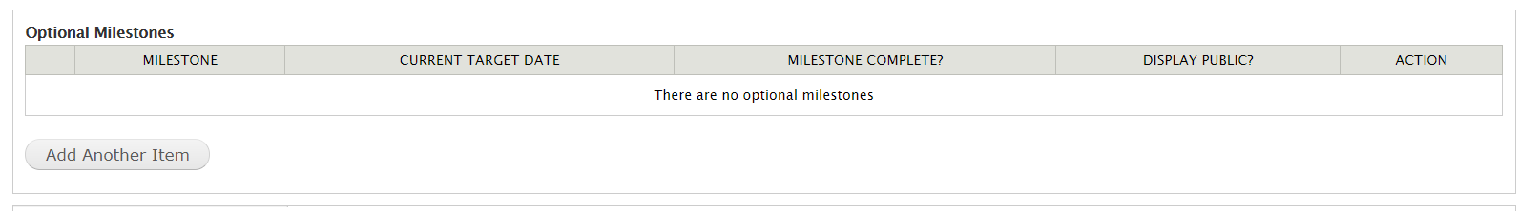

**16**

1. **Optional Milestones** **–** Projects may want to track additional milestones - outside those that are required per Appendix B. The system allows users to add optional milestones to track those events. To add an optional milestone, select the ‘Add Another Item’ button.

3

5

4

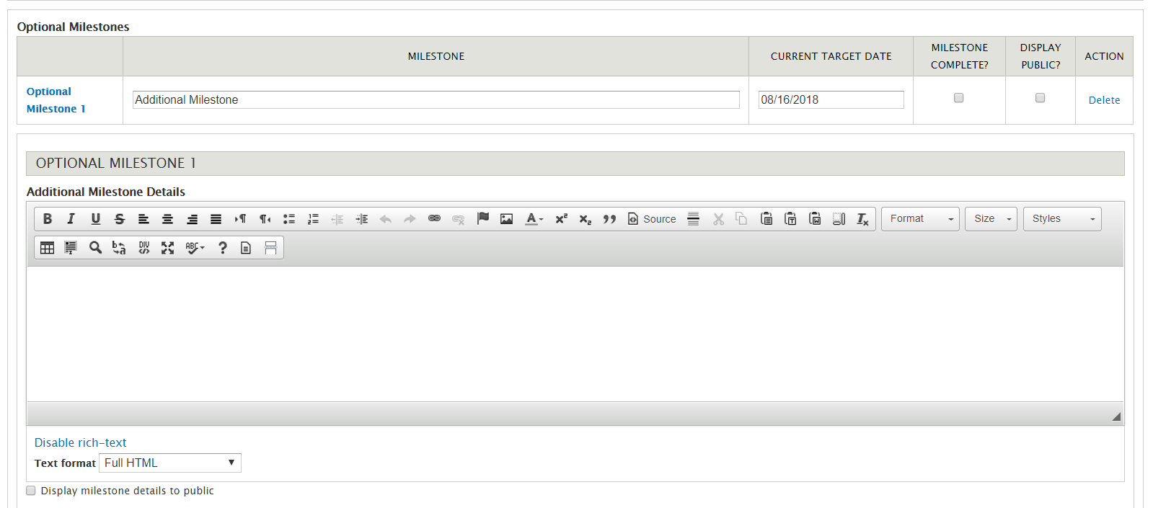

**19**

**18**

**17**

1. **Adding an Optional Milestone –** After selecting the ‘Add Another Item’ button, you will see a row appear where you can enter the optional milestone name and enter a target date. You may choose whether you would like this milestone to be public facing by selecting the ‘Display Public’ checkbox.
2. **Additional Milestone Details –** You can add details to this optional milestone if needed.
3. **Display Milestone Details to Public –** Selecting this checkbox will display any information which is entered in the milestone details text box to the public site. If you leave the checkbox unselected, then any details that you enter within the milestone details text box will not display publicly but will be stored on the form.

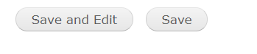

2

1

1. **Save and Edit**: Once at the bottom of the form, selecting ‘Save and Edit’ will save all the data entered on the form and you will remain on the form to continue to add/edit data.
2. **Save:** If you are ready to Save your Action and view the draft which you just created, select the ‘Save’ button at the bottom of the form.

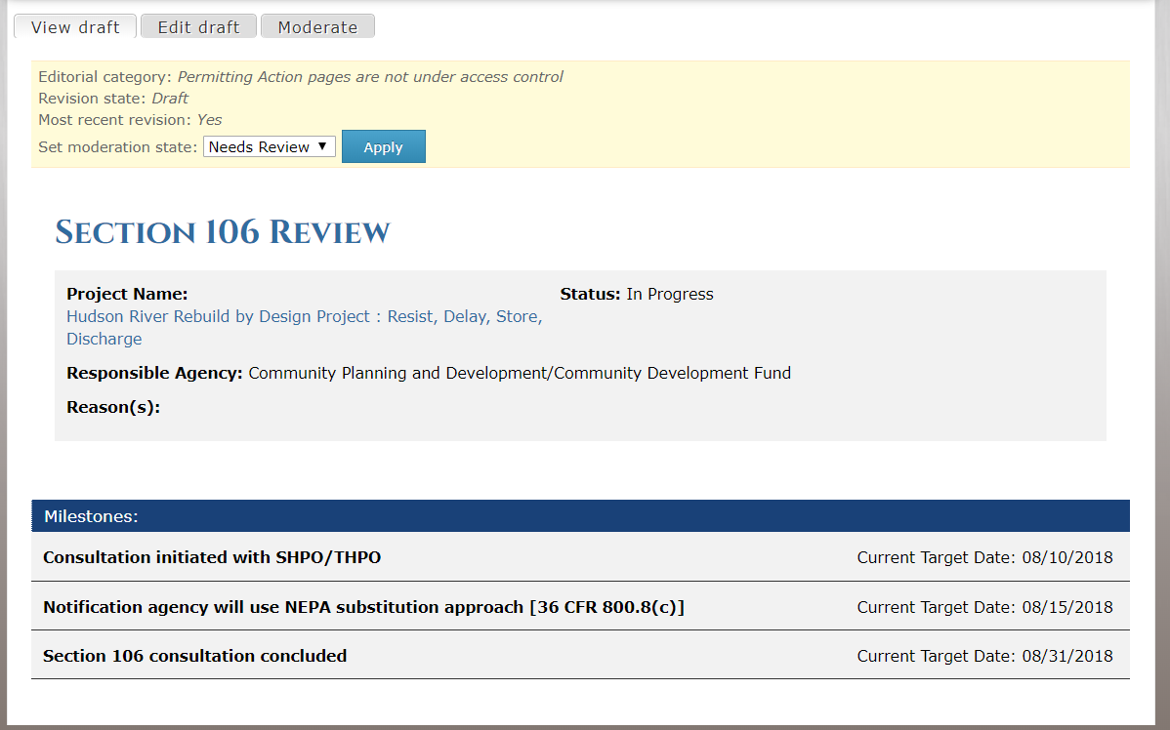

3

1

2

1. **View Draft:** After selecting ‘Save’ you will be taken to the page to view your draft. The draft is a page that shows you exactly what the Action page will look like before it is ‘Published’ to be public facing.
2. **Edit Draft:** If you are not ready for the Draft to be public facing and would like to continue making edits, then select the ‘Edit Draft’ button.
3. **Moderation State:** When a project *AUTHOR* creates, or edits an Action, that information is saved in a **DRAFT** state. Actions will remain in **DRAFT** until an *AUTHOR* sets the status to **NEEDS REVIEW**; at which point they should manually/orally inform a project *APPROVER* that the Action is ready for review and publication to the public-facing website.

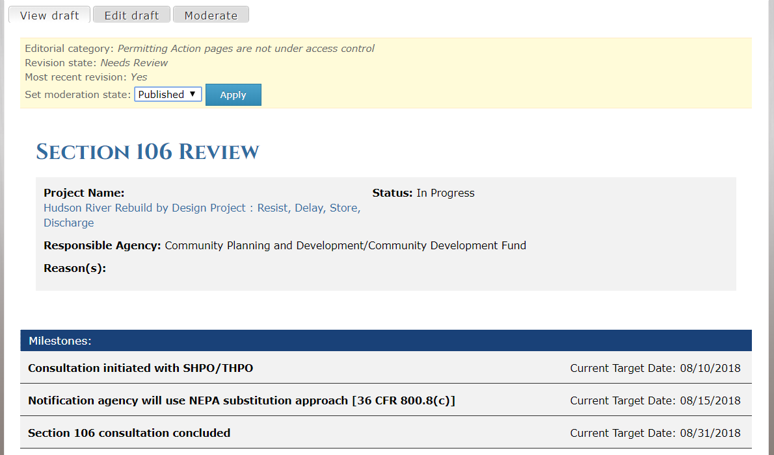

1

1. Once the Draft is placed in Needs Review, The Approver role can then move the Action page from **NEEDS REVIEW** to **PUBLISHED t**o publish the Action data to the public facing site.

.

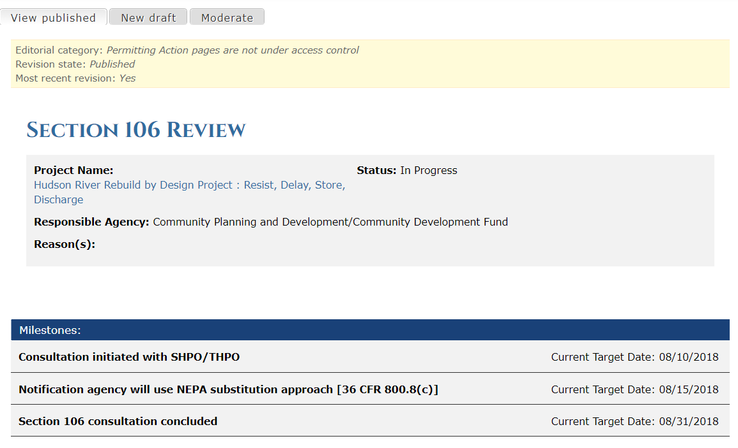

1

1. Once the Action is Published, you will see a ‘View Published’ tab appear. This tab allows you to view your published Action while logged in as a user.

You have now successfully created an Action for a Project and made the Action public facing!

NOTE: Projects that are Major Infrastructure Projects and have a Project Category as ‘Other’ will not be public facing nor will any of its Actions be public facing. They MUST still go through the general workflow of DRAFT -> Needs Review -> Published

### Editing an Action

To edit an action, log into the Dashboard and select the ‘Action’ tab. The Actions tab is an easy way to find a specific Action within a Project.

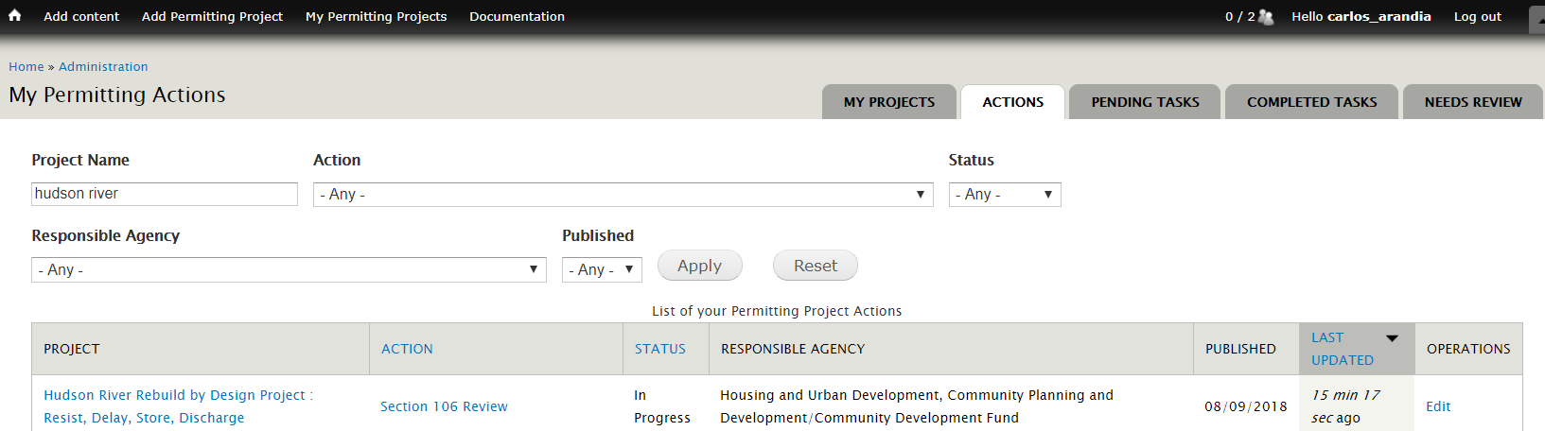

1

1. See the screenshot above which indicates the ‘Actions’ tab.

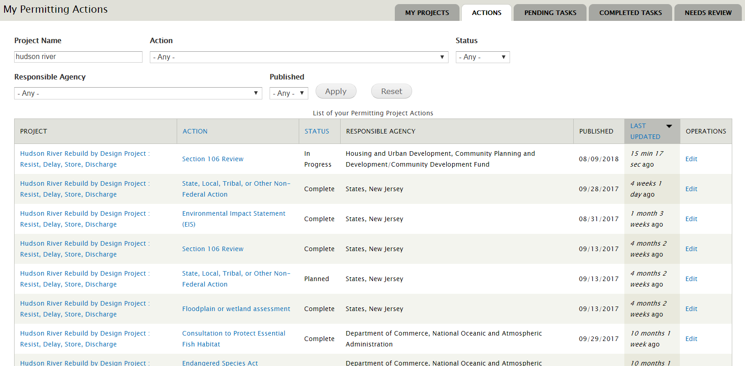

2

1

1. Once on the Actions tab, type the Project for which you’d like to view the Actions for in the ‘Project Name’ field. In the example above, Hudson River has been typed within the Project field. Once ‘Apply’ is selected, only Actions for the Hudson River project will display.
2. Locate the Action which you would like to Edit. In this scenario above, the Environmental Impact Statement (EIS) Action is the Action that needs to be edited. I will locate the EIS Action and select the ‘Edit’ link from the Operations column.

NOTE: Once you select the Edit button, this will take you the Action’s form where you can edit the information entered from section 4.6.1.

### Setting Project Dependencies

You can set up dependencies between Actions within a project in the Timeline tab. The dependency fields are located at the bottom of the Timeline tab. Below is a demonstration of linking an Environmental Impact Statement to a Section 106 as a dependency.

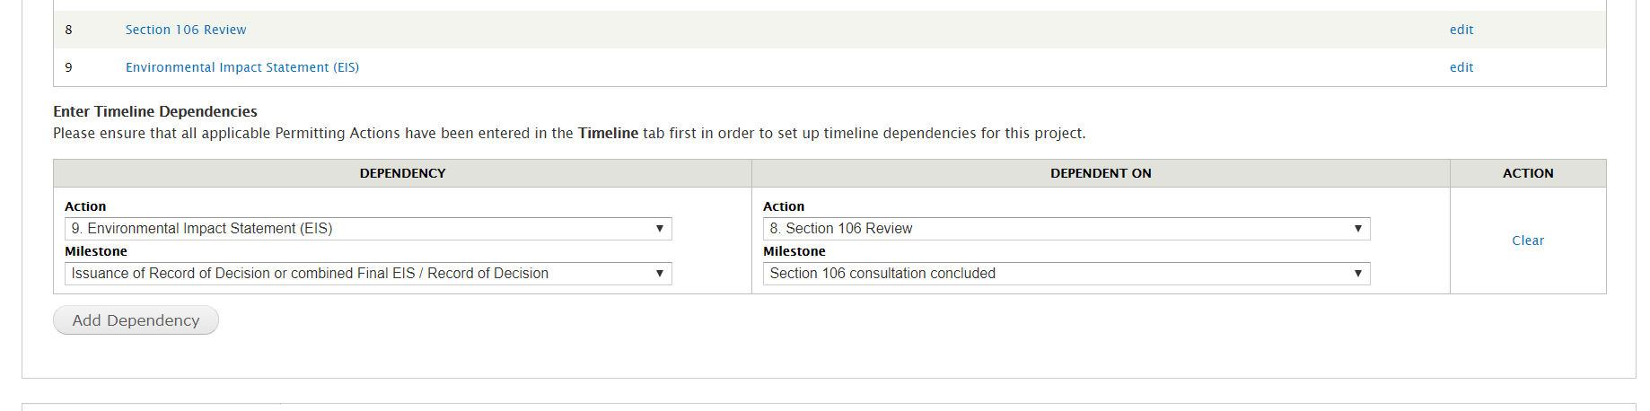

2

1

**NOTE:** You can only set up dependencies with existing Actions that you have for the project. Therefore, it is best to add all applicable Actions for the project first in order to have a full list of dependencies to set up.

1. To continue to add more dependencies, select the ‘Add dependency button’
2. To remove a dependency, select the ‘Clear’ link.

As always, any changes made must be published through the Draft -> Needs Review -> Published workflow. For project dependencies, the ‘project’ page will need to go through the workflow for the dependencies to be considered ‘official.’

## Outcomes Tab

The Outcomes tab allows entry of Environmental and Community Outcomes which are the qualitative and quantitative descriptions of how a project’s projected effects change over time and the community-based processes and mitigation measures developed to address those effects.

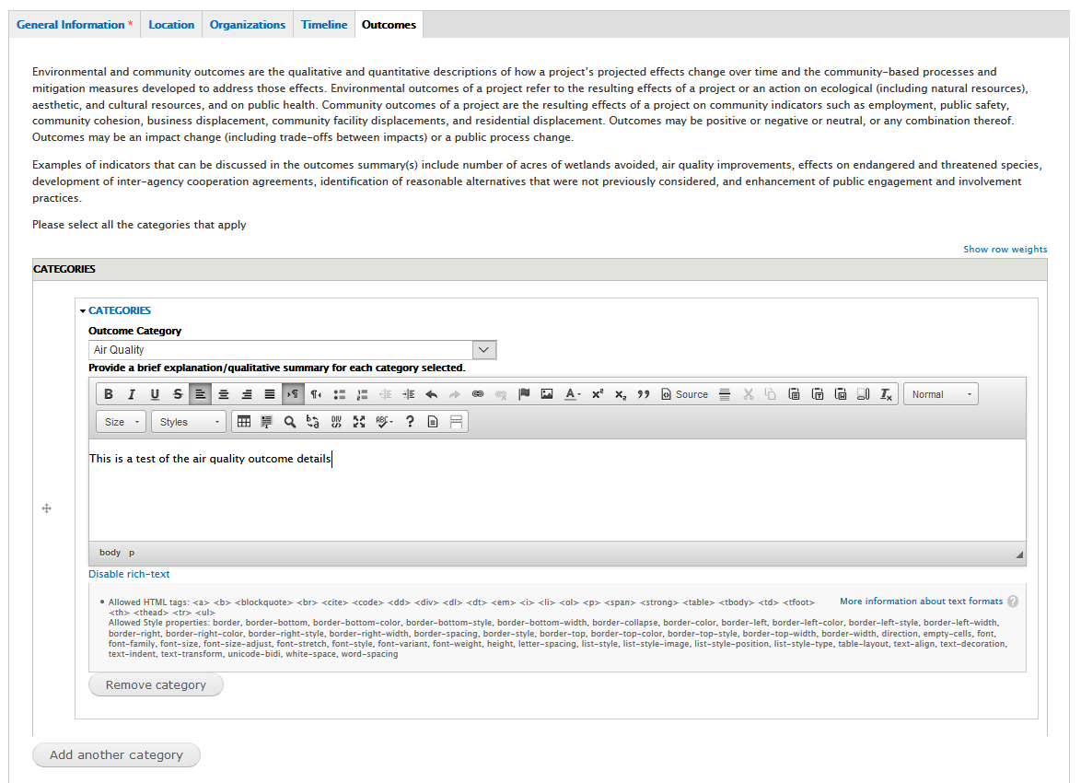

**3**

**4**

**2**

**1**

1. **Outcome Category –** This field contains a drop down list of Categories that can be selected. The followinig Categories are avalble for selection

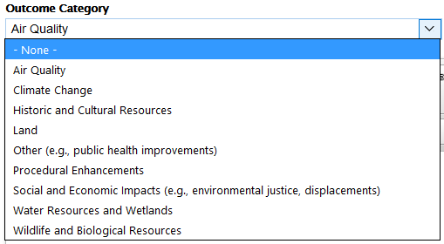

1. **Provide a brief explanation/qualitative summary for each category selected –** Use this text field to provide additional details of the Category selected.
2. **Remove category –** Selecting this will remove the Category and its contents in the text box
3. **Add another category –** Selecting this will allow for additional Categories to be selected

At the bottom of the Outcomes Tab page there is a question with checkbox selections

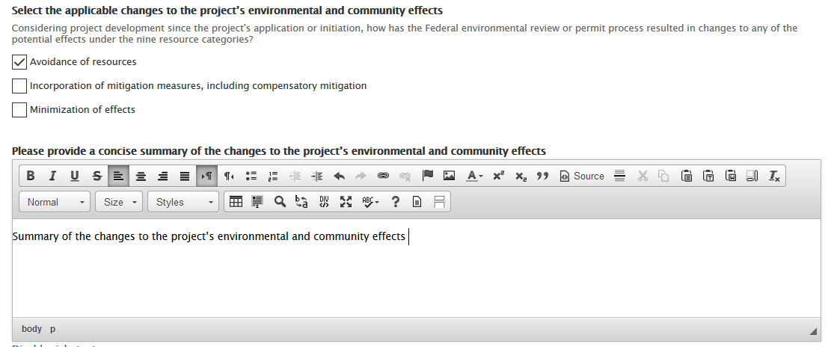

1. **Select the applicable changes to the project’s environmental and community effects** – Multi checkbox selection
2. **Please provide a concise summary of the changes to the project’s environmental and community effects –** Provide details and any additional information in this text box

## One Federal Decision Tab

Please see **Section 9** of this document for information regarding Major Infrastructure Projects and the One Federal Decision tab.

# Project Workflow

Within the Permitting Dashboard Data Entry Application there are two workflows that dictate what is published to the public website. There is a workflow to publish the high-level project information, and another workflow to publish each individual Action within the Timeline tab.

## Publishing High-level Project Information

Publishing a project will push all updated content within the General Information, Location, Organizations and Outcomes tabs to the public website. Publishing a project WILL NOT publish your Actions within the project. However, publishing the project will publish any project dependencies that have been set up within the Timeline tab.

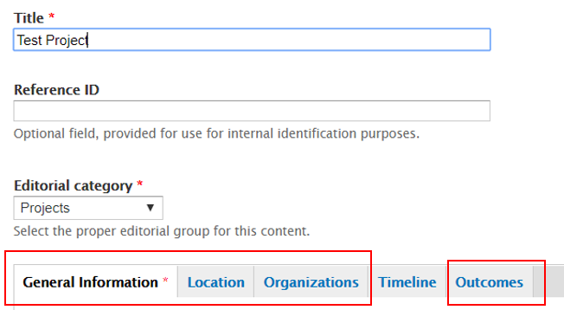

1

1. These four tabs have information pushed to the public site when a project is published

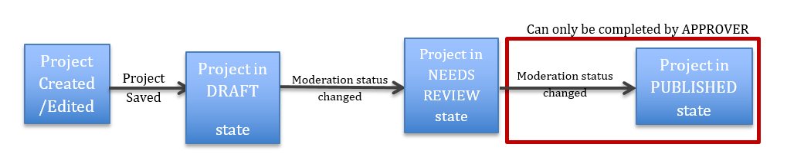

When a project *AUTHOR* creates, or edits a project, that information is saved in a **DRAFT** state. Projects will remain in **DRAFT** until an *AUTHOR* sets the status to **NEEDS REVIEW**; at which point they should manually/orally inform a project *APPROVER* that the project is ready for review and publication to the public-facing website.

Only the *APPROVER* role can move a project’s status to the **PUBLISHED** status.

Note: The project must go through all stages (including NEEDS REVIEW) in order to publish correctly on the public-facing website.

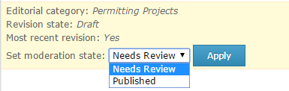

1. **Set Moderation State** – Changes the status of a project:

* **Draft**
* **Needs Review**
* **Published**

## 

# Public Website View

## Viewing / Searching for Projects

All Projects in the Permitting Dashboard can be viewed by accessing the following link: <https://www.permits.performance.gov/projects>. The page will display as seen below

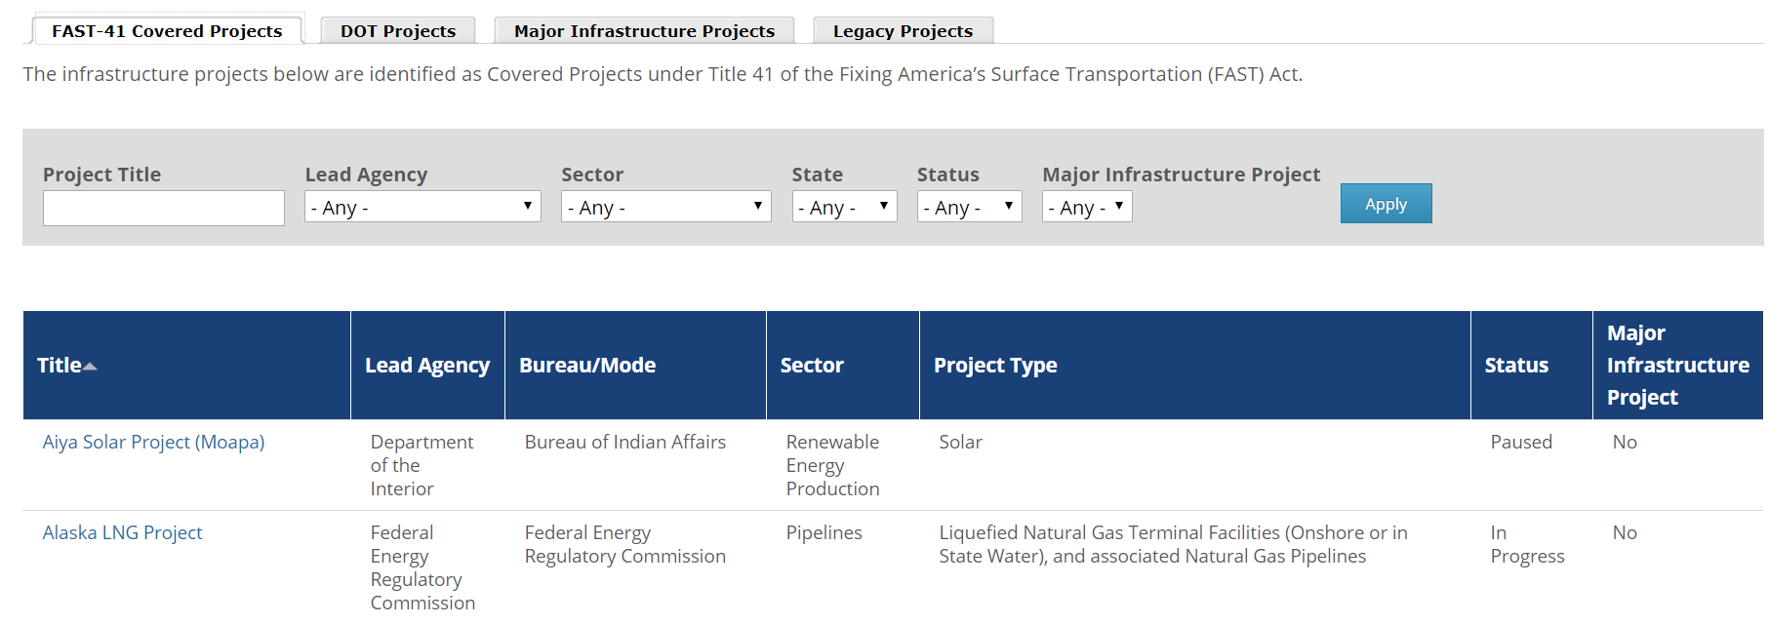

Notice that the data table has separate Tabs that separate projects by their Classification:

* Fast-41 Covered Projects
* DOT Projects
* Major Infrastructure Projects
* Legacy Projects

Once you are in a given tab, Projects can be further filtered by:

* Project Title
* Lead Agency
* Sector
* State
* Status
* Major Infrastructure Project or Project Category

## Download or Export of Project Data

Project Data can be downloaded into an Excel sheet.

* 1. To download project data, please use the Permitting Dashboard Data Portal: <https://data.permits.performance.gov>

## Project Map Data

Published projects’ location information can be viewed on an Interactive Map on the Permitting Dashboard website. You may access the interactive map several ways:

* Go to <https://www.permits.performance.gov/> and view a (non-interactive version of the) map on the bottom left of the page

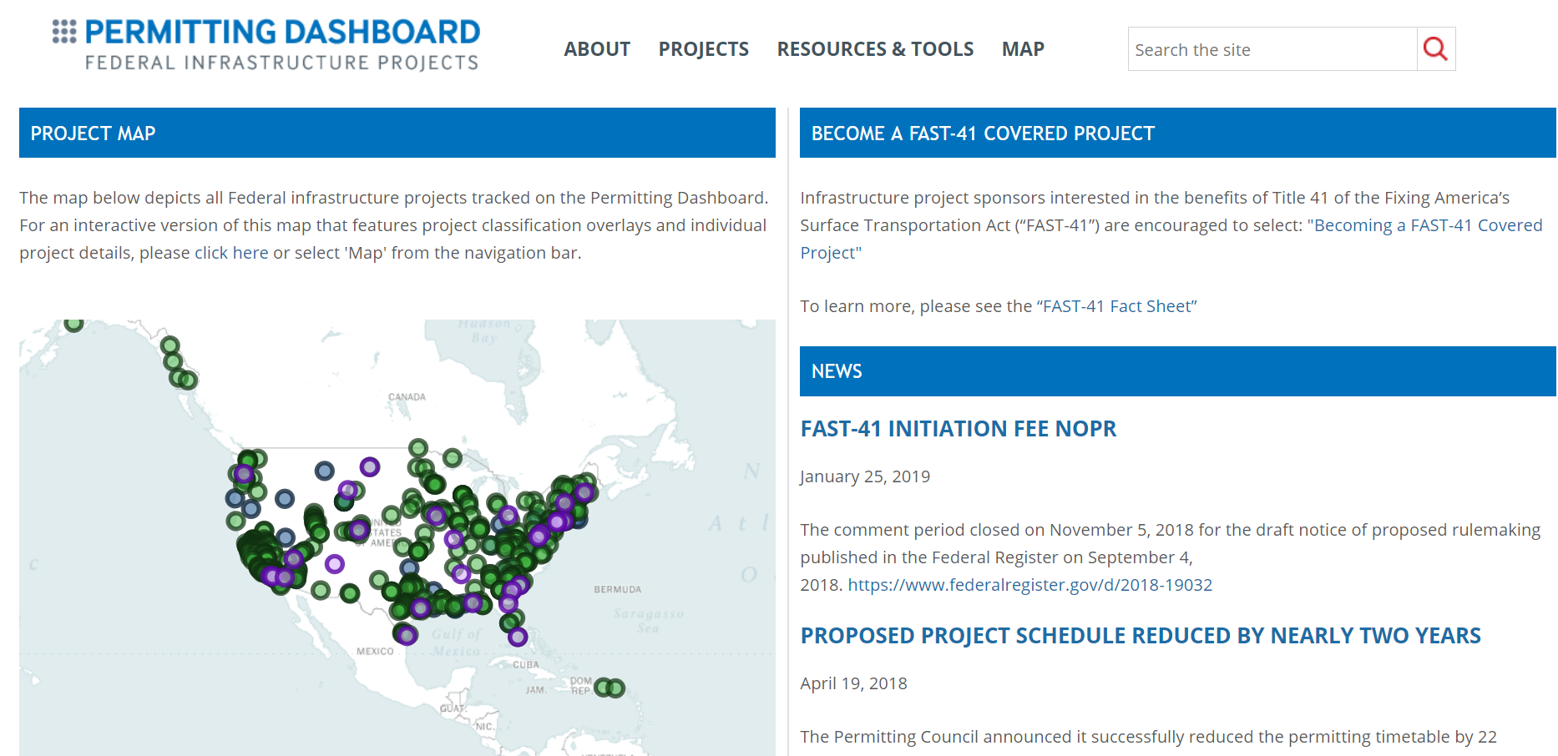

2

1

* The interactive version of the map can be accessed by selecting:
  1. The Map menu link
  2. The Map display

Once on the interactive map page, several features will be available for use.

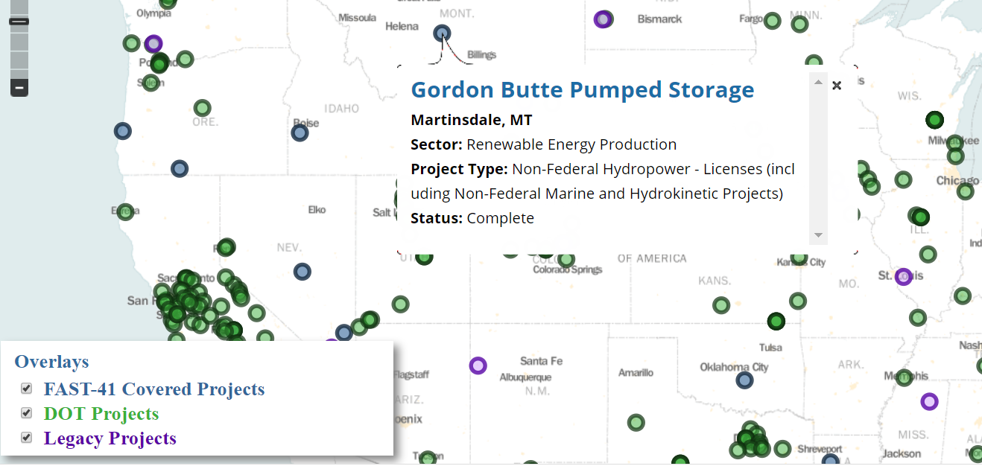

3

2

1

1. Clicking the dots on the map displays individual projects along with a summary of additional information for the project
2. Selecting the project title from the pop up directs you to more specifics about the project
3. Use the 'Overlay' box at the bottom left of the map to reveal or hide projects based on their classification. (Note that the colors in the ‘Overlay’ box correlate to the colors of the dots on the map)

## Environmental and Community Outcomes

Entries made for Environmental and Community Outcomes can be viewed on a Project’s page. Once a project is selected from the dashboard:

* 1. On the project’s page, scroll down to view the Environmental and Community Outcomes entered for the project
  2. Select the arrow(s) for each category below the ‘Categories’ header to expand and view summaries
  3. Selections made for ‘Changes to the project’s environmental and community effects’ will display here

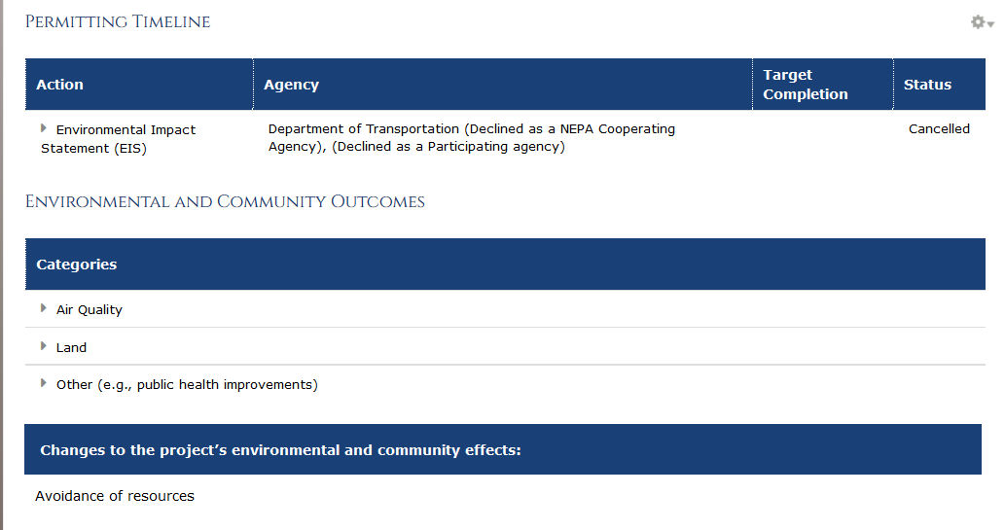

**2**

**4**

**3**

**1**

NOTE: For more information and instructions on how to enter data for the Environmental and Community Outcomes for a project, see section 4.7 of this document.

# Coordinated Project Plan Quarterly Certification (Dashboard Admins only)

Coordinated Project Plans (CPPs) are to be reviewed or updated on a quarterly basis. To ensure this occurs, the Dashboard contains capabilities for Dashboard Administrators per agency to mark a project’s CPP as reviewed or updated.

On the first day of every quarter, an email will be sent from the Dashboard to Dashboard Administrators per agency that contains a link to mark the CPP as reviewed/updated.

Once the link from the email is selected, you will be brought to the Pending Tasks tab on the Dashboard site to view all current projects within the agency which you are associated with that need their CPP’s reviewed/updated.

Projects on the Pending Tasks tab display per agency. Please mark the projects that are only applicable to you within the agency.

**Pending Tasks tab**

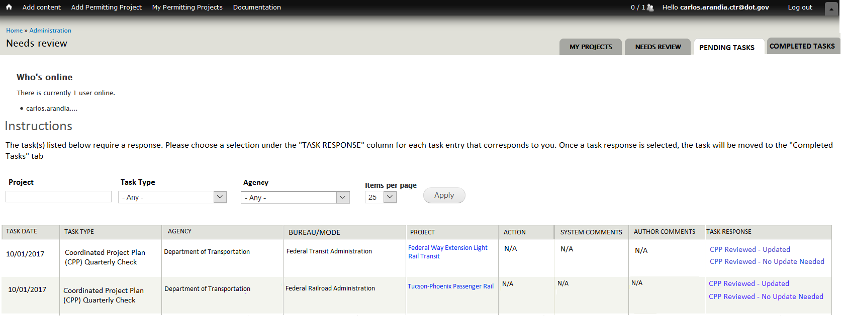

2

1

* + - 1. **Task Response** - Responses for your project’s CPP are located under the “Task Response” column
      2. **Completed Tasks** - Once a response is selected, the task will no longer display within the “Pending Tasks” tab and will move to the “Completed Tasks” tab

**Completed Tasks tab**

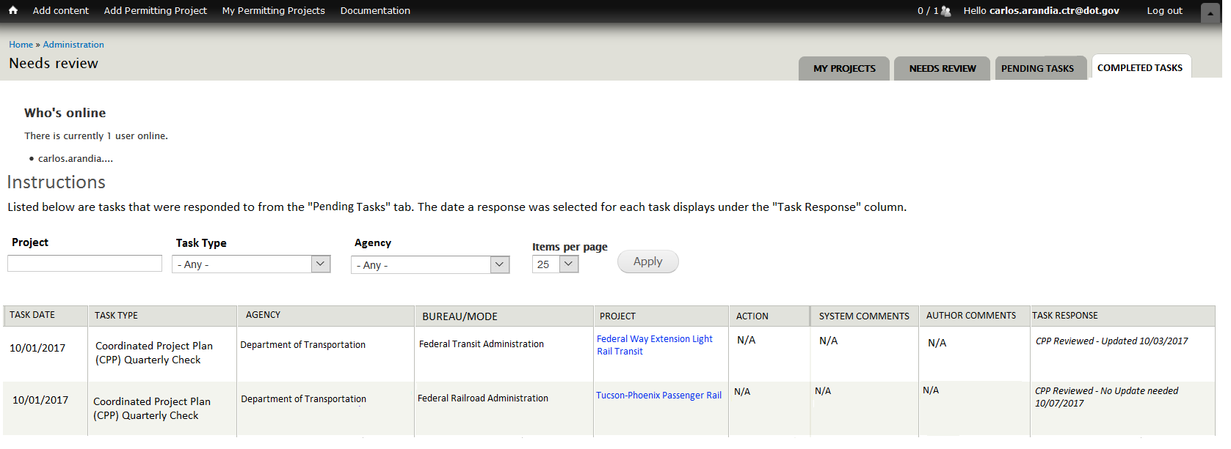

1

1. **Task Response** - Note that under the “Task Response” column, the selection made for the specific project’s CPP from the Pending Tasks tab displays along with the date the response was selected.

# Extending Dates into Executive Director Review on The Permitting Timetable

## Extending Dates into Executive Director Review as a Project Author or Approver

When any milestone’s Current Target Completion date within an Action is modified to a date that is greater than 30 days of the furthest out milestone Original Target Date, then the Action will be sent to the Executive Director for review, when the Action is moved from DRAFT to NEEDS REVIEW.

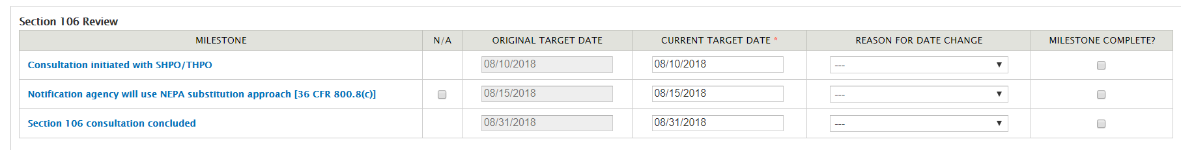

When the Action is prompted for Executive Director review, a text box will appear (as shown below). Use this text box to enter details and any additional information regarding the extension. The text entered in this box will be displayed to the Executive Director only and will not be displayed publicly and plays an important part in the Executive Director’s decision to acknowledge the extension.

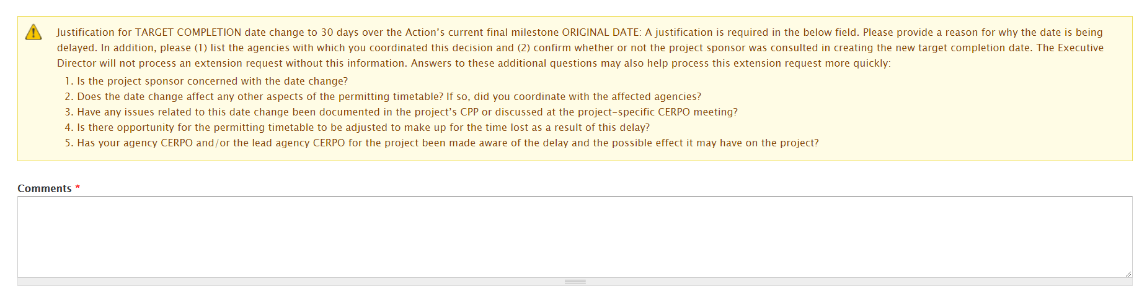

Once the Executive Director approves/acknowledges the extension, the Action will be moved to the “NEEDS REVIEW” revision state where an Approver may then PUBLISH the Action.

## Approving/Acknowledging Extensions as the Executive Director

When an Action’s revision state is moved to “Executive Director Review” then the user with the Executive Director role will receive an email notification with the link to access the PENDING TASKS tab of the Dashboard to acknowledge the extension.

**Pending Tasks Tab**

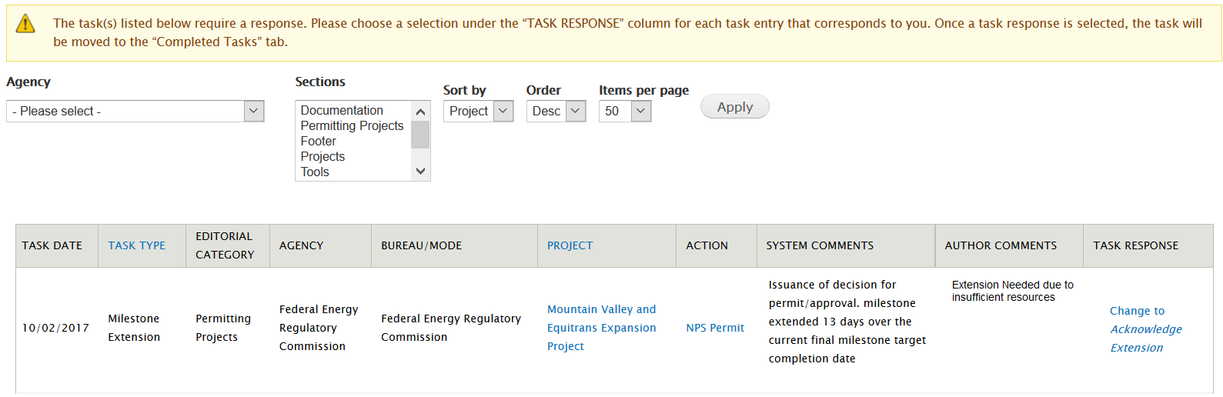

6

7

5

4

10

9

8

3

2

1

1. **Task Date**: Date that the extension request was created
2. **Task Type**: The type of task is listed within the ‘Task Type’ column
3. **Editorial Category**: Pertains to the type of data listed
4. **Agency**: Lists the Lead Agency of the project involved with the Action extension
5. **Bureau/Mode**: Lists the Bureau/Mode of the project involved with the Action extension
6. **Project**: Lists the project involved with the Action extension (clicking the project name in this column will take you to the project’s page)
7. **Action**: Lists the Action involved with the Milestone Extension (clicking the Action name in this column will take you to the Action’s page)
8. **System Comments**: The text in this column is system generated and contains the specific milestone within the Action that is requesting an extension of 30+ days over the furthest out Baseline Date. The number of days in this column is shown as the number of days extended over the 30 days. **(i.e. if a milestone is extended 35 days over the furthest out Baseline Date, then the system comments will state this as ‘5’ days over)**
9. **Author Comments**: The text in this column displays any comments that the user has regarding this extension which may help the Executive Director to acknowledge the extension
10. **Task Response**: This column contains the response to the extension. If ‘Change to Acknowledge Extension’ is selected, then the Action that contains the milestone that is being extended will then enter the Needs Review revision state. Once in the Needs Review revision state, a Dashboard Approver can log in and Publish the Action.

If “Acknowledge Extension” is selected, then the entry will move from the PENDING TASKS tab into the COMPLETED TASKS tab with the time the Task Response was selected.

**Completed Tasks Tab**

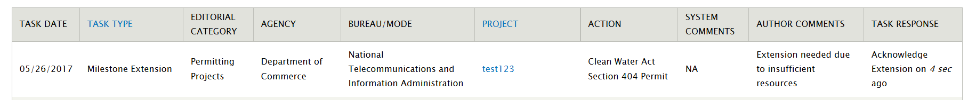

# Major Infrastructure Projects: One Federal Decision

If your project is a Major Infrastructure Project, then you will need to indicate whether the project is being processed in accordance with the One Federal Decision framework. See below for instructions on how to complete the One Federal Decision task.

1. Log onto the Dashboard and search for the specific project. In the example below, I will locate the ‘Jordan Cove’ project.

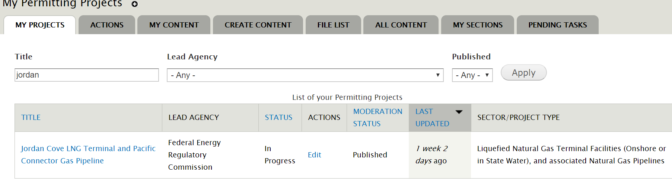

2

1

1. Select the project link

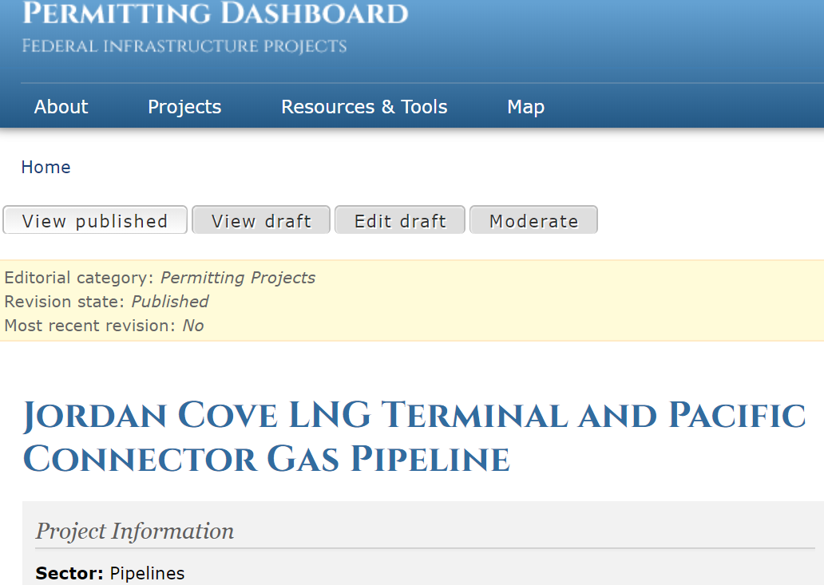

3

1. Once on the project page, select ‘Edit Draft’ or, select ‘New Draft’ if the project does not currently have a working draft.
2. Once you are on the project’s data entry form, ensure that the Major Infrastructure Project button is selected as ‘Yes’

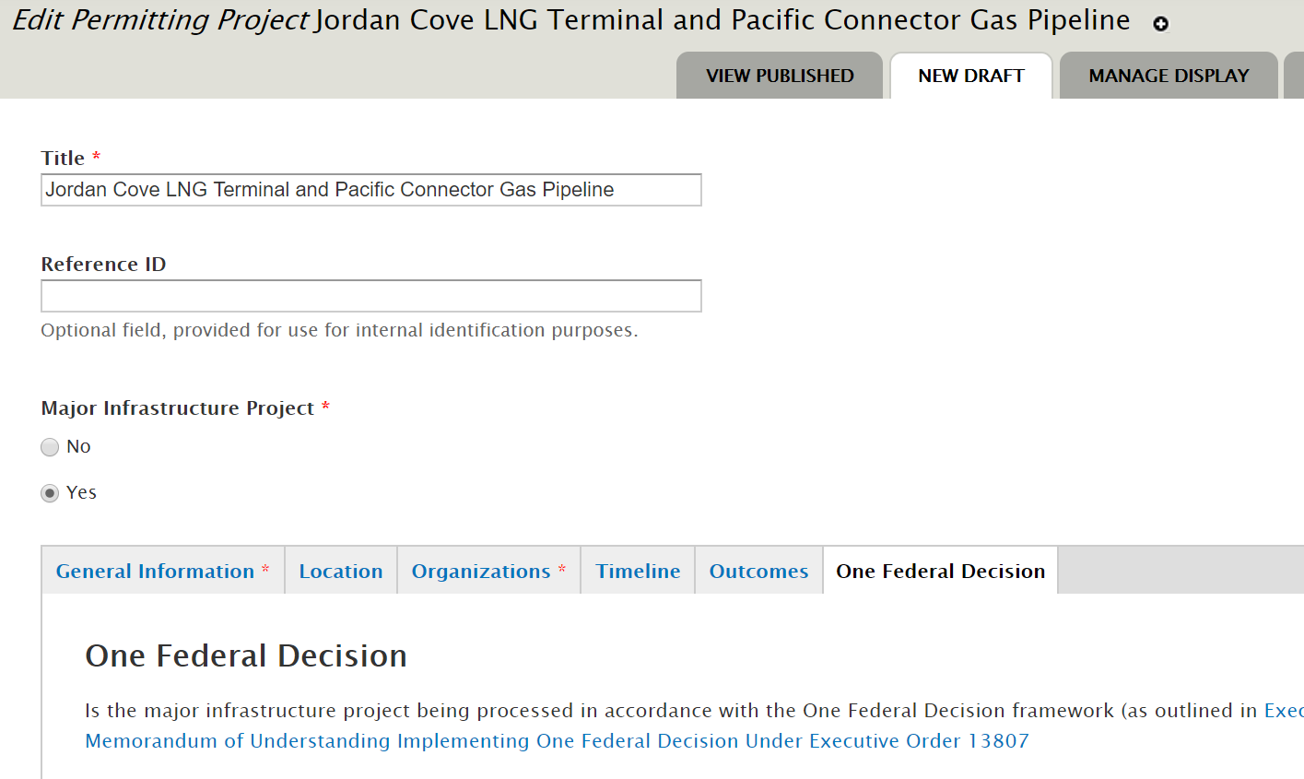

5

4

1. Once ‘Yes’ is selected, notice that the ‘One Federal Decision’ tab appears.

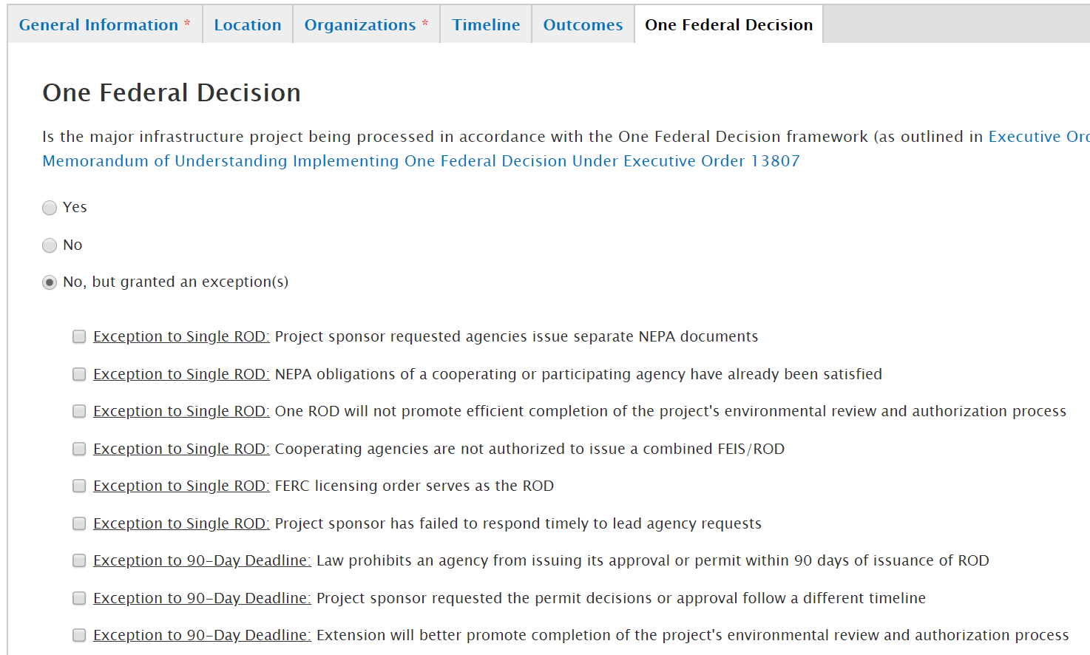

6

1. Notice within the One Federal Decision tab, you may indicate Yes, No, or No but granted an exception(s) for your Major Infrastructure Project’s One Federal Decision selection.
2. Once you have made a selection select the ‘Save’ button on the bottom of the page.

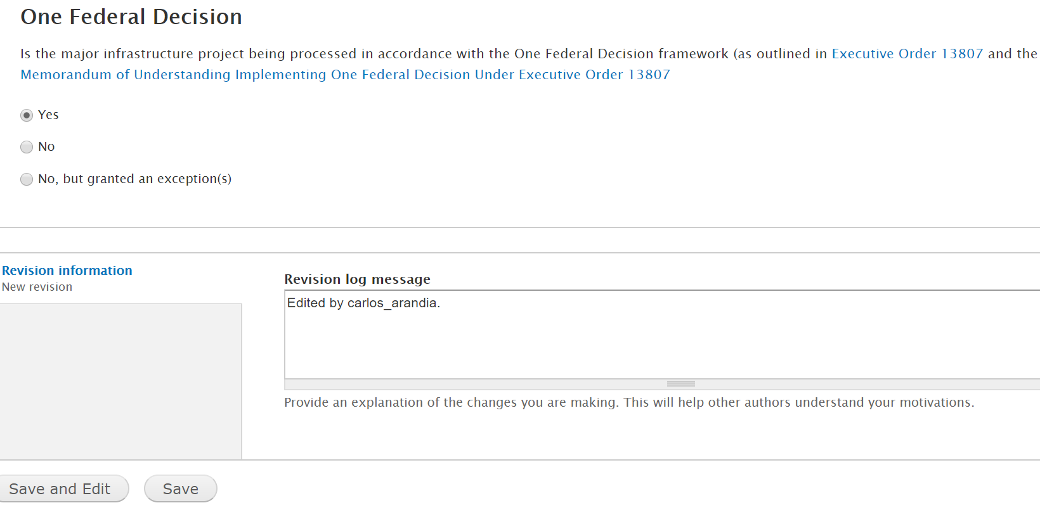

7

1. After selecting ‘Save’ you will be brought to view the project page where you must publish the project in order to make your One Federal Decision selection official. The Lead Agency of the project can move the project from DRAFT to NEEDS REVIEW. An Approver can then move the Project from NEEDS REVIEW to PUBLISHED.

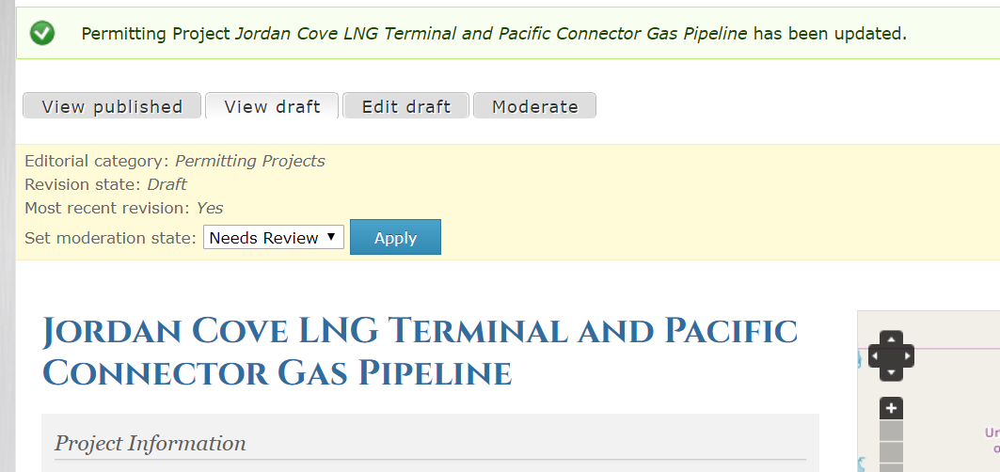

8

**NOTE:** You may edit the One Federal Decision selection for your project at any time by editing the project and making a different selection then publishing the project again.

**NOTE:** The selection made for the One Federal Decision framework is NOT public facing.

# Down-Scoping an Environmental Assessment (EA) or an Environmental Impact Statement (EIS) to a Categorical Exclusion (CE)

The following steps demonstrate how to indicate that an Environmental Assessment has been Down-scoped to a Categorical Exclusion on the Permitting Dashboard site.

1. Log on to the Permitting Dashboard
2. Select the Actions tab to search for a specific permitting action on the top right of the screen

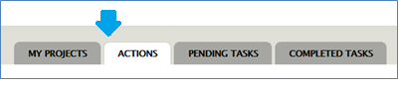

1. Set the filters to search for the specific permitting action that you want to indicate as down-scoped and select “apply”

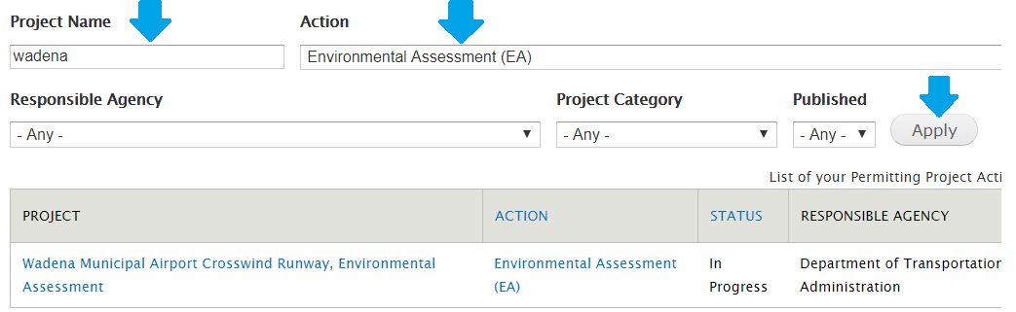

1. Once located, open the page by selecting the permitting action

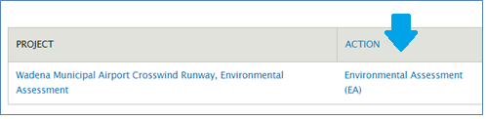

1. Select new draft on the permitting action page (or edit draft if there already is a working draft)

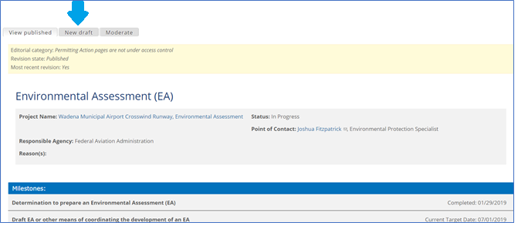

1. Locate the Status field and set it to Class of Action Changed

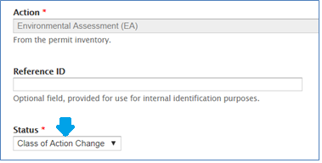

1. Locate the Action Outcome field and set it to Categorical Exclusion

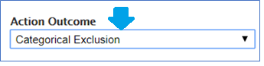

1. Make any other changes necessary to the permitting action
2. Once done, select “Save” at the bottom of the form

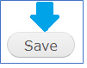

1. Once ready, move the permitting action through the workflow to publish the changes from Draft to Needs Review. Then an approver can publish the action by moving it from Needs Review to Published.

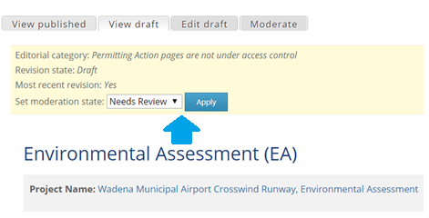

1. Ensure that the project status is also set to Class of Action Changed
2. Select the “My Permitting Projects” link at the top of the page

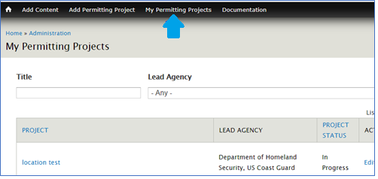

1. Locate the project by selecting “my projects”

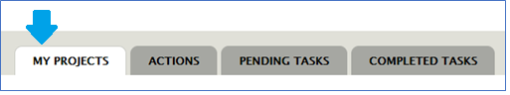

1. Search for the Project

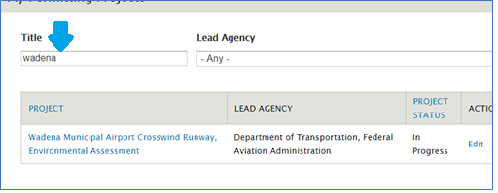

1. Click on the project title

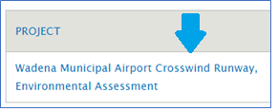

1. Select new draft (or edit draft if there already is a working draft)

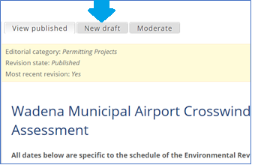

1. Locate the project status field and set it to Class of Action Changed

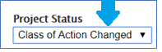

1. Make any other changes necessary to the permitting project
2. Once done, select “Save” at the bottom of the form



1. Once ready, move the permitting project through the workflow to publish the changes from Draft to Needs Review. Then an approver can publish the action by moving it from Needs Review to Published.

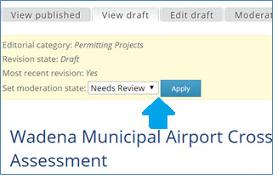

1. You have successfully indicated the project as down-scoped to a Categorical Exclusion!

# Indicating an Environmental Impact Statement (EIS) as re-classified to an Environmental Assessment (EA)

The following steps demonstrate how to indicate that an Environmental Impact Statement has been re-classified to an Environmental Assessment.

1. Log on to the Permitting Dashboard
2. Select the Actions tab to search for a specific permitting action on the top right of the screen



1. Set the filters to search for the specific Environmental Impact Statement action that you want to indicate as re-classified to an Environmental Assessment and select “apply”

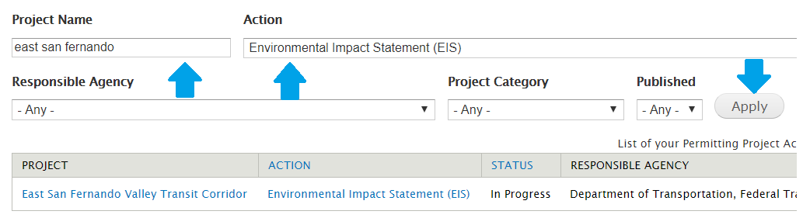

1. Once located, open the page by selecting the permitting action

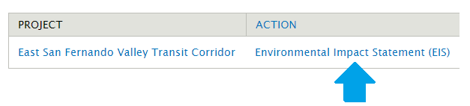

1. Select new draft on the permitting action page (or edit draft if there already is a working draft)

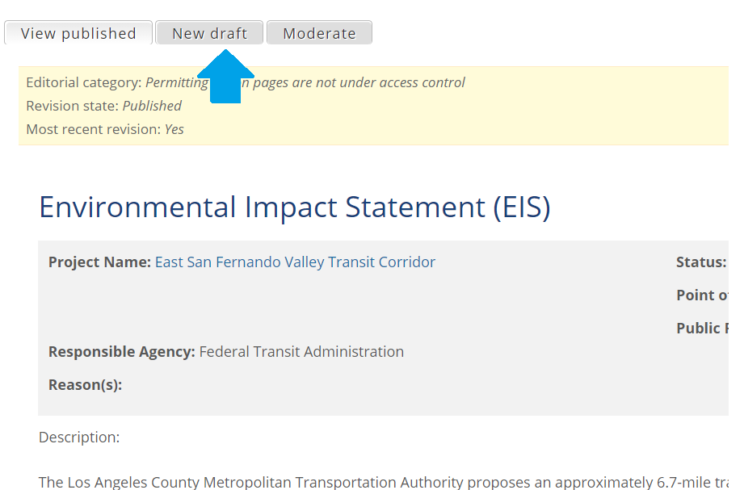

1. Locate the Status field and set it to Class of Action Changed

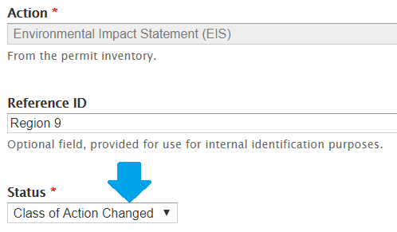

1. Locate the Action Outcome field and set it to Categorical Exclusion

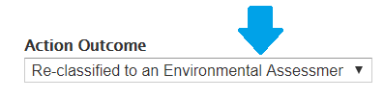

1. Make any other changes necessary to the permitting action
2. Once done, select “Save” at the bottom of the form



1. Once ready, move the permitting action through the workflow to publish the changes from Draft to Needs Review. Then an approver can publish the action by moving it from Needs Review to Published.

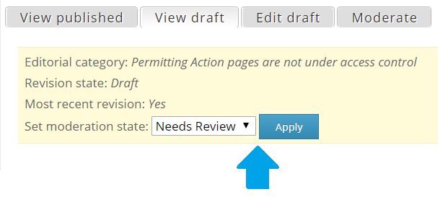

1. Ensure that an Environmental Assessment is then added to the project. Please see section 4.6.1 for instructions on how to create a permitting action.